UNIVERSITY OF CALIFORNIA, BERKELEY
College of Engineering
Department of Electrical Engineering and Computer Sciences

EE 105: Microelectronic Devices and Circuits Spring 2008

Final Exam
Time allotted: 3 hours

NAME: _________________________ _________________________ _________________________
(print) Last First Signature
STUDENT ID#: ____________________
INSTRUCTIONS:
- Use the values of physical constants provided below.
- SHOW YOUR WORK. (Make your methods clear to the grader!)
- Clearly mark (underline or box) your answers.
- Specify the units on answers whenever appropriate.

 | Electron and Hole Mobilities in Silicon at 300K
  PHYSICAL CONSTANTS
  Description | Symbol | Value
  Electronic charge | q | 1.6×10⁻¹⁹ C
  Boltzmann’s constant | k | 8.62×10⁻⁵ eV/K
  Thermal voltage at 300K | V_{T} = kT/q | 0.026 V
  Note that V_{T} ln(10) = 0.060 V at T=300K
  PROPERTIES OF SILICON AT 300K
  Description | Symbol | Value
  Band gap energy | E_{G} | 1.12 eV
  Intrinsic carrier concentration | n_{i} | 10¹⁰ cm⁻³
  Dielectric permittivity | ε_{Si} | 1.0×10⁻¹² F/cm

SCORE:

- 2 extra blank sheets are provided on page 13 and 14 in case you need more space for your answers. Make sure to include a pointer to the overflow space in your answer.
Problem 1 [15 pts] PN Junction Diode
- A Si PN junction consists of equally doped N and P region, N_{D} = N_{A} = 10¹⁷ cm⁻³. Both P and N regions are 1 µm thick, and the junction area is 100x100 µm².
  - What is the built-in potential of the diode?

  - What is the small signal equivalent circuit of the diode when the forward bias current of the PN junction is 1 mA? Find the values of the circuit elements in the equivalent circuit.

  - What is the small signal equivalent circuit of the diode when it is reverse biased at 5V? Find the values of the circuit elements.

Problem 2 [24 pts] Basic Concepts
- Please answer the following questions.
Question | Answer
  - [3 pt] (Single choice) The current in the collector region of an NPN bipolar transistor is conducted by (A) electron, (B) hole, (C) both.

  - [3 pt] (Single choice) The drain current in a PMOS FET is carried by (A) electron, (B) hole, (C) both.

  - [3 pt] (Single choice) The channel of an NMOS FET is doped to be (A) N type, (B) P type, (C) neither.

  - [3 pt] (Single choice) Reducing the gate oxide thickness of an MOSFET will (A) increase its transconductance (g_{m}), (B) decrease its transconductance, (C) have no effect. Assume the MOSFET is biased at a fixed drain current.
Answer and reason for d)

  - [3 pt] (Single choice) Reducing the thickness of the base layer in a BJT will (A) increase its transconductance (g_{m}), (B) decrease its transconductance, (C) have no effect. Assume the BJT is biased at a fixed collector current.
Answer and reason for e)

  - [3 pt] What is the main benefit of replacing gate oxide by high-k dielectric materials in MOSFET?
Answer for f):

  - [3 pt] What are the causes of the output resistances for long- and short-channel MOSFET, respectively
Answer for g):

Problem 3 [25 pts] BJT Amplifier
- Consider the bipolar amplifier shown below.
BJT Parameters
I_{S} = 10⁻¹⁶ A
V_{A} = 50V
β = 100
C_{π} = 20 fF
C_{μ} = 5 fF
C_{CS} = 10 fF

Circuit Parameters:
V_{CC} = 3V
R_{E} = 5 kΩ

  - [2 pt] What is the topology of this amplifier (common emitter, …etc)?

  - [3 pt] Find the expression of the voltage gain, expressed in terms of small-signal parameters.

  - [4 pt] Find the expressions of the input and output resistance.

  - [4 pt] What DC voltage, V_{DC}, is required to bias the transistor so the transconductance of the BJT is 40mS?

  - [4 pt] Find the numeric value of the voltage gain.

  - [4 pt] Draw the relevant capacitances on the circuit diagram above. How many poles does this circuit have?

  - [4 pt] Find the 3-dB bandwidth of this circuit.

Problem 4 [20 pts] MOS Amplifier
- Consider the following amplifier:
NMOS:
V_{TH} = 0.5 V,
μ_{n}C_{ox} = 200 μA/V²,
λ = 0.1V⁻¹

PMOS:
V_{TH} = -0.5 V,
μ_{p}C_{ox} = 100 μA/V²,
λ = 0.1V⁻¹

R_{S} = 100Ω
  - [5 pt] What is the function of this amplifier? Explain the functions of each transistor (M₁ to M₆).

  - [5 pt] Find the expression of the voltage gain.

  - [5 pt] Find the expression of the input and output resistance.

  - [5 pt] Find the numeric value of the output resistance.

Problem 5 [20 pts] Cascode Amplifier
- For the cascode amplifier shown below:
NMOS:
V_{TH} = 0.5 V,
μ_{n}C_{ox} = 200 μA/V²,
λ = 0.1V⁻¹

PMOS:
V_{TH} = -0.5 V,
μ_{p}C_{ox} = 100 μA/V²,
λ = 0.1V⁻¹

I_{REF} = 100 µA
(W/L)₅ = (W/L)₆ = (W/L)₇ = 10
(W/L)₂ = (W/L)₃ = (W/L)₄ = 10
(W/L)₁ = 40

  - [2 pt] Find the expression of the voltage gain (you can keep only the dominant term).

  - [3 pt] Find the expression of the output resistance (you can keep only the dominant term).

  - [5 pt] Find the voltage at Node X, Y, and A, B.

  - [5 pt] In order for all transistors to stay in saturation, what is the maximum and minimum voltage at output?

  - [5 pt] If the widths of M₂, M₃, and M₄ are doubled (i.e., (W/L)₂ = (W/L)₃ = (W/L)₄ = 20), how do the voltage gain and output resistance change?

Problem 6 [20 pts] Differential Amplifier
- Consider a differential amplifier shown below:
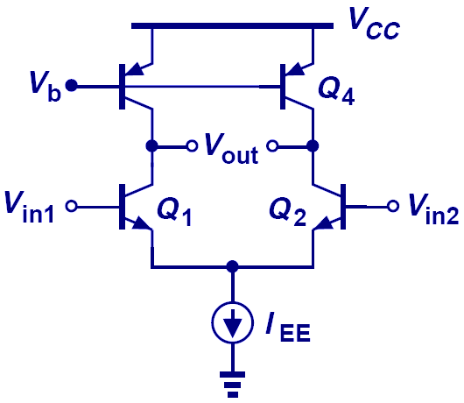  Q  4  Q  3  +  –  +  – | I_{EE} = 5.2 mA  V_{A} = 52 V for NPN transistor  V_{A} = 26 V for PNP transistor  β = 100 for all transistors
  - [5 pt] Find the expression and numeric value of the voltage gain of the differential amplifier.

  - [5 pt] If the current source has a shunting (i.e., in parallel with I_{EE}) resistance of 100KΩ, and the early voltages of Q₃ and Q₄ differ by 1%, find the common mode to differential mode voltage gain (both expression and value).

  - [5 pt] What is the common mode rejection ratio (CMRR) of the amplifier in Part b)?

  - [5 pt] The circuit below is also a differential amplifier. How does it differ from the circuit above? Does it still provide immunity to common mode noise?
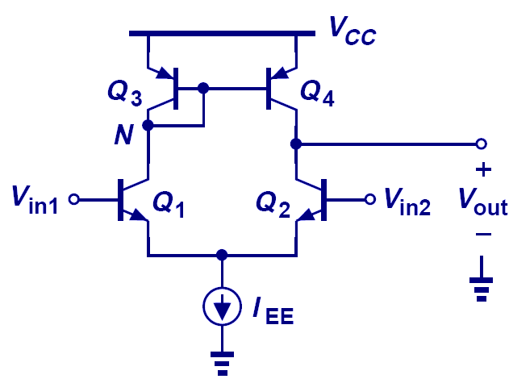
+
–

(Additional Pages)

(Additional Pages)

