San Mateo, July 19, 2001 - Keynote Systems has found significant Internet backbone slowdowns in the aftermath of yesterday's CSX train derailment in Baltimore, probably due to damage to fiber optic lines. The effects have been evident on Keynote's Internet Health Report, which shows the performance between principal Internet nodes in the U.S.. (The Internet Health Report is used in the control centers of a number of major ISPs and can be viewed by the public at www.internethealthreport.com ). Since this site is updated every hour and the performance problems when repaired will no longer be visible, we have included copies of a couple of this morning's screens showing the backbone performance problems. (Figures 1 and 2 at the end of this message).

This morning, both PSINet and Genuity have been experiencing peering problems with most of the other backbones, particularly in the Eastern corridor, including peering locations in New York, Philadelphia and Washington, D.C. These problems show up as red boxes where the ISP names intersect on The Internet Health Report. By clicking on one of these boxes you can drill down to see individual performance between specific cities for those particular ISPs. We have also been seeing performance slowdowns in Seattle, L.A. and Atlanta. Whether these are due to the train wreck is not currently known for certain, but may be symptomatic of traffic rerouting around the train wreck and the Eastern corridor.

According to postings on the NANOG discussion list, the train wreck resulted in a fiber optic line cut, which affected many cities in the Northeast. Also according to one posting, Alternet/UUNET/Worldcom, Abovenet/MFN, Mindspring, and PSINet posted messages about effects they were experiencing due to the train derailment, but because the train derailment involves potentially hazardous materials, no provider has an estimated time to repair. Evidently telecommunications repairs need to be made in the tunnel where the train derailment and resulting fire occurred.

A review of Web sites measured from East Coast cities on affected backbones shows dramatic performance slowdowns for some web sites starting at 3:00pm on Wednesday, at the time of the train wreck, some with problems continuing through this morning. (See figures 3 through 8 at the end of this message, and note that we include measurements from both affected and unaffected locations -- that implies that the site itself wasn't having problems, but that it was the accessibility to the site that was having problems.) Users accessing sites over the affected backbones have undoubtedly been experiencing severely degraded response times.
In situations like this, traffic is rerouted around the broken link. Depending on the amount of traffic and extent of the break, performance on the Internet overall may be affected to a lesser or greater extent.

=====

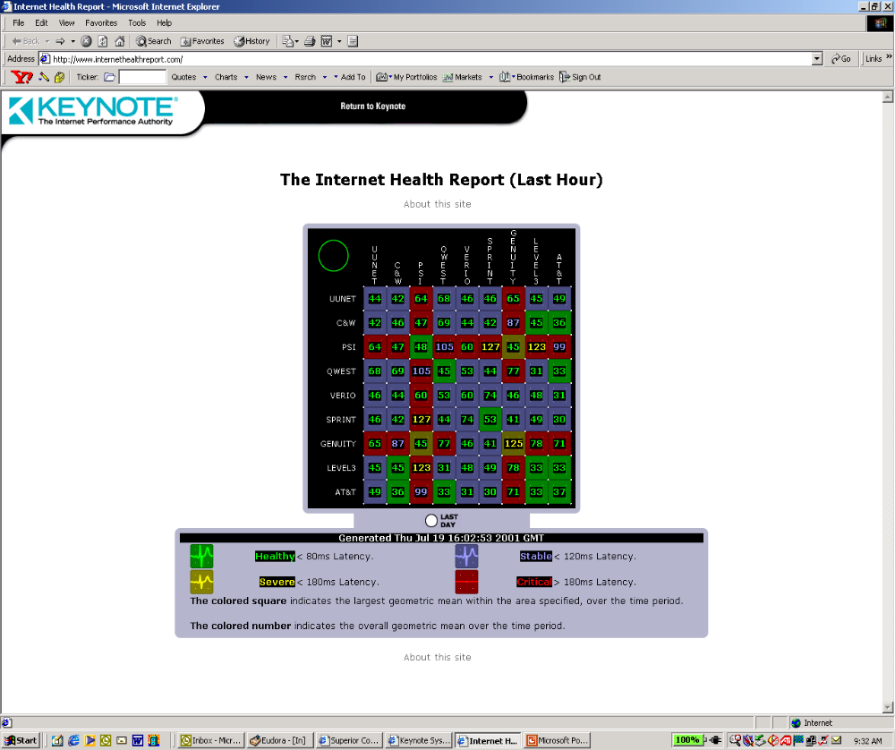

Figure 1: Internet Health Report, overall, for July 19, 11:00 am - noon EDT

( http://www.internethealthreport.com See "about this site" on the actual web page for a detailed explanation. Basically, the number in each box is the geometric mean of all the agents on one backbone to all of the agents on the other backbone; the box color is red if at least one of the underlying agent-to-agent pairs is > 180 ms latency. It's also possible that there are problems within a backbone; that's indicated, e.g., by "Genuity:Genuity." A geometric mean is the product of the measurements divided by the number of measurements; it's more accurate for Internet statistics than an untrimmed arithmetic mean.)

=====

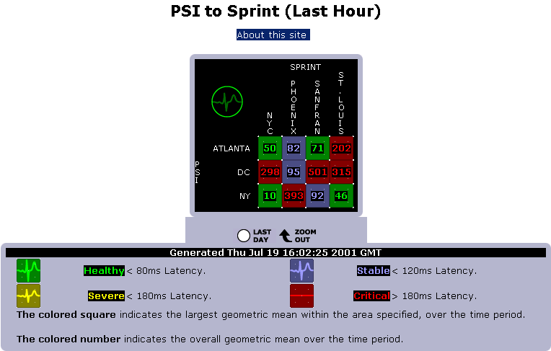

Figure 2: Internet Health Report, PSI:Sprint for July 19, 11:00 am - noon pm EDT

(showing major problems between Sprint and PSI, primarily with PSI's D.C. location.)
=====

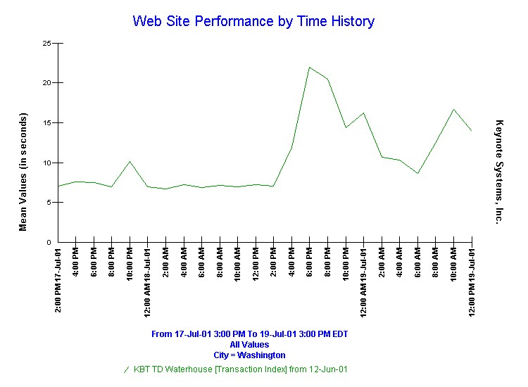
Figure 3: A stock purchase transaction from Washington DC PSI
=====

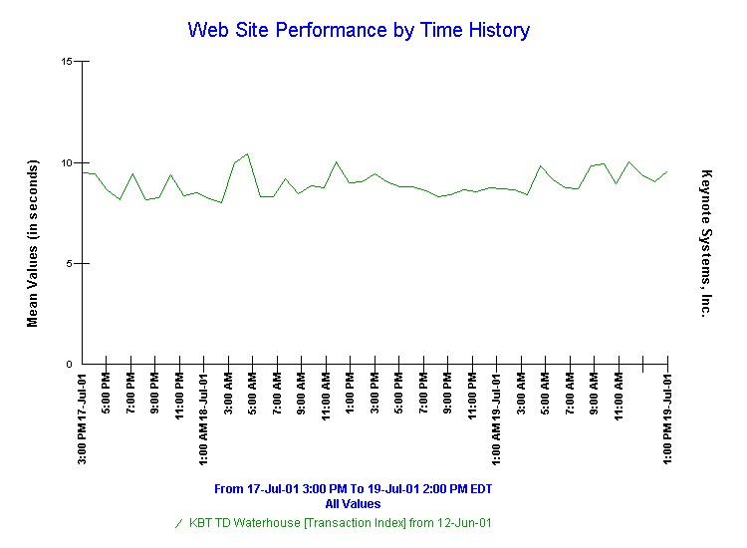

Figure 4: The same stock purchase transaction from nine US cities other than Washington DC PSI

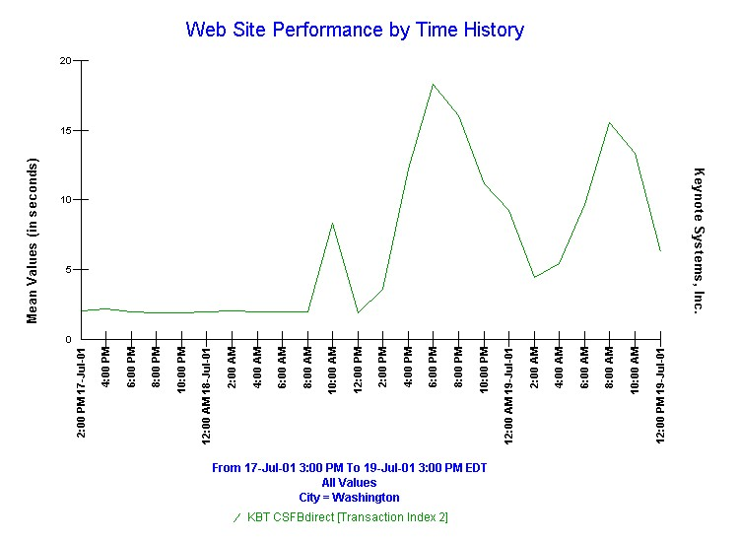

Figure 5: Stock purchase transaction with firm #2 from Washington DC PSI

=====

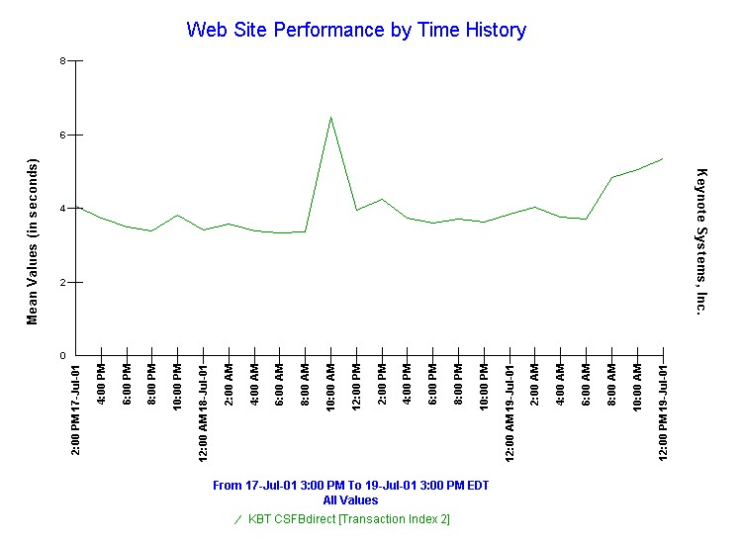

Figure 6: Second stock purchase transaction for firm #2 from nine US cities other than Washington DC PSI

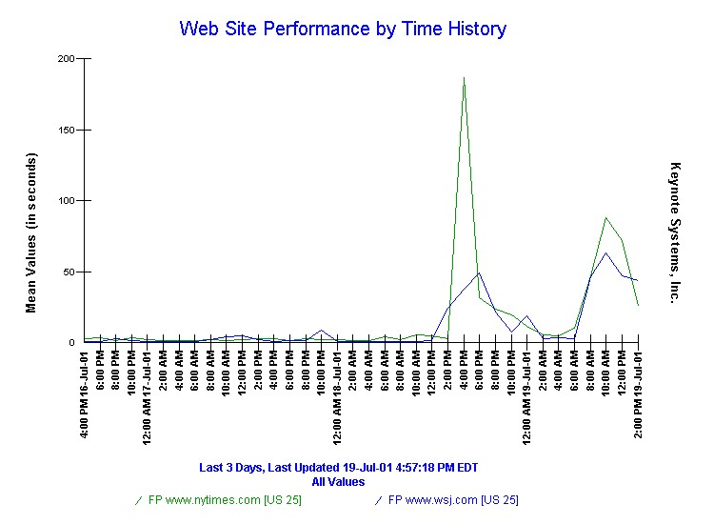

Figure 7: NY Times and Wall Street Journal home pages from Washington DC PSI

=====

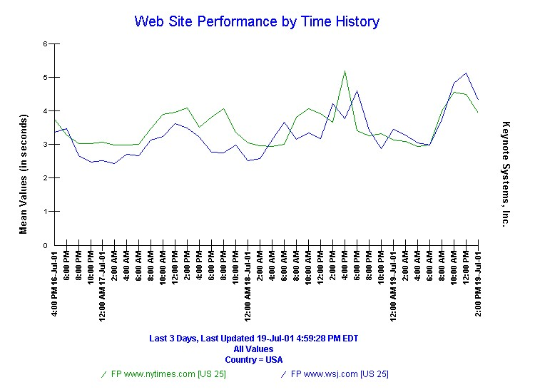

Figure 8: NY Times and Wall Street Journal home pages from 65 US-wide locations (multiple ISPs in 25 US cities)

