EECS140 Midterm 2
Spring 2018
Prob. | Score
1 | /16
2 | /30
3,4 | /30
5,6 | /20
Total | /96
Name__________________________

SID___________________________

1) Unless otherwise indicated, you may make the following assumptions:
- All transistors are biased in saturation with V_{ov}=0.5V
- V_{DD}=10V, V_{tn}=1V, V_{tp}= -1V
- M3, and M6 are identical, M5 is 3 times wider
- All capacitors are assumed to be zero except C_{C}, C₁, and C₂ .
2B
2A
C_{C}
C₂
5
1A
4
1B
3
6
R_{Z}
10mA
C₁
- To minimize offset, what is the appropriate choice for (W/L)₄ in terms of (W/L)_{2B} ?

- What is the common mode input range (min and max)?

- What is the output swing (min and max)?

- If C₁=0, C₂=10 pF, and C_{c}=1 pF, what is the positive slew rate?

- If C₁=0, C₂=2 pF, and C_{c}=1 pF, what is the negative slew rate?

- If C₁=0, C₂=10 pF, and C_{c}=1 pF, what is the negative slew rate?

- A different amplifier with the same topology has the following parameters. You may ignore the pole/zero doublet from the mirror.
g_{m1,2} | R_{o1} | g_{m4} | R_{o2} | C₁ | C_{C} | C₂
10mS | 10k | 10mS | 1k | 10n | 100n | 1μ
  - If Cc=0 (magically we will assume no Cgd4 for this part only), what are the uncompensated pole frequencies?
ω_{p1,u}=
ω_{p2,u}=

Now assuming Cc is given as above,
  - If Rz=0, what is the location of the RHP zero?
ω_{z}=

  - What value for Rz should we use to push the RHP zero to infinity?
R_{z}=

On the following pages, assuming that we have chosen Rz correctly as above,
  - plot the magnitude of the second stage gain.
  - plot the overall impedance seen at the first stage output (including R_{o1}, C₁, C_{C}, and any effects of Miller multiplication),
  - plot the magnitude of the first stage gain,
  - plot the magnitude and phase of the overall gain. Label any poles and zeros clearly.
  - Estimate the phase margin for this value of C_{C}.

  - What is the maximum feedback factor and closed loop gain for which the amplifier has a 45 degree phase margin?
f=
A_{cl}=
PM=
1
1k
1M
1G
1
100
10,000
|A_{v2}|
|A_{v2}|
1
100
10,000
|A_{v1}|
|A_{v1}|
1
1k
1M
1G
10
1K
100K
|Z_{o1}|
1
1k
1M
1G
rad/s
|Z_{o1}|
2e) Impedance at first stage output, |Z_{o1}|
2d) Second stage gain – |A_{v2,0}|
2f) First stage gain, |A_{v1}|
rad/s
rad/s
1
100
10,000
|A_{v}|
|A_{v}|
1
1k
1M
1G
rad/s
-180
-90
0
Phase(A_{v})
1
1k
1M
1G
Phase(A_{v})
-270
2g) op amp Bode plot
rad/s
Label any poles and zeros clearly!
3) [8] A ua741 op-amp has a DC gain of one million and a pole at 1 Hz. It is used in feedback with a feedback factor f=0.001 .
- What is the approximate closed-loop gain,

- percent gain error,

- closed-loop pole location,

- unity gain bandwidth,

- and time constant of the step response?

4) [22] A particular diode D1 has a saturation current of 0.01 pA, and at 100 μA current at room temperature the diode voltage has a temperature coefficient of -1.5 mV/K. You are using copies of this diode to make a bandgap reference as in Lab 4, with D2 composed of 100 copies of D1. Assuming that the current in both diodes is maintained at 100 μA at room temperature
- What is the voltage on D1 at room temperature?

- What is the voltage on D2 at room temperature?

- What is the difference between the two diode voltages at 200K, 300K, and 400K?

- What is the temperature coefficient of the voltage on D2?

- Roughly what is the right value for R1?

- On the following page, carefully sketch by hand the voltage on D1, the voltage on D2, and the difference between them as a function of temperature from 200K to 400K.
- On the same plot, if R₃=R₂=4 R₁, sketch V_{ref} vs. temperature from 200K to 400K.

800mV
900mV
1V
0 K
100mV
200mV
300mV
400mV
500mV
600mV
700mV
300 K
1.1V
1.2V
It will help your grade if you draw carefully and label the voltage values of any dots that you draw.
5) [15] For the amplifier below (from https://en.wikipedia.org/wiki/Amplifier)
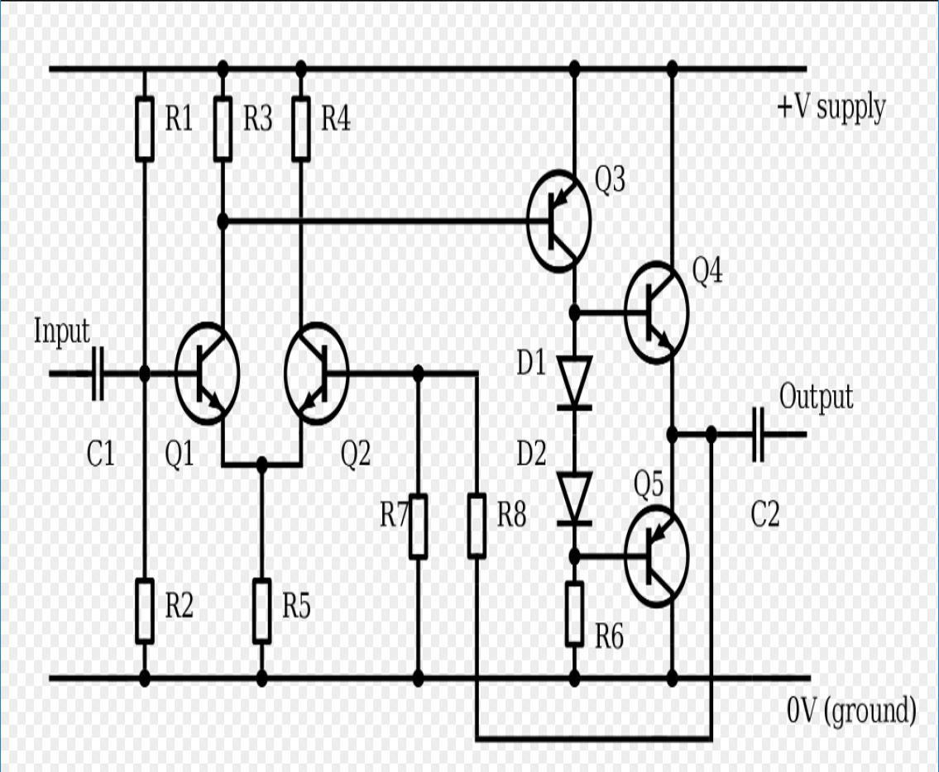
VCC
0
- Circle the first stage, second stage, and output stage

- Write an expression for the tail current in terms of VCC, and component values

- Estimate the common mode gain of the first stage (open loop)

- Estimate the differential gain of the first stage (open loop)

- Estimate the second stage gain (open loop)

- Estimate the open-loop output impedance

- What is the feedback factor and closed loop gain of the amplifier?

- If you needed to add a compensation capacitor, draw where you would but it.

6) A two stage op-amp has a gain of 10,000, a first stage pole at 1 kHz and a second stage pole at 100 kHz.
- What is the maximum feedback factor for which this op-amp has a phase margin of 45 degrees?

- If you increase the capacitance to ground at the output of the first stage, where do you need to move the first stage pole so that the amplifier has 45 degrees of phase margin in unity gain feedback?

