EECS140 Midterm 2
Spring 2016
Prob. | Score
1 | /10
2 | /29
3 | /16
4 | /10
5 | /15
Total | /80
Name__________________________

SID___________________________

- For the op-amp below, assume that:
- All transistors are biased in saturation
- All capacitors are assumed to be zero except C_{C}, C₂ , and C_{gs} for all transistors.
- g_{m}r_{o} >> 1 for all combinations of g_{m} and r_{o}
2B
2A
C_{C}
C₂
5
1A
4
1B
3
6
The same op-amp will be used in several different feedback circuits.
  - [2] The spec requires that the output be able to swing to within 200mV of ground, and 150mV of the positive supply. List all constraints on overdrive voltages.

  - [2] When used in feedback the closed-loop gain must be 5 +/- 1%. What is the constraint on the open-loop gain of the amplifier?

  - [2] When used in feedback with a closed-loop gain of 5, the desired bandwidth is 200M rad/s. What is the constraint on the unity-gain bandwidth?
  - The amplifier is also to be used in unity-gain feedback driving a 100pF load, and the desired open-loop phase margin is 70 degrees.
    - [2] What is minimum possible value for g_{m4}? (answer should be in Siemens)

    - [2] What are the constraints on g_{m1} and I_{tail}? (in terms of other circuit values)

- A particular design of the op-amp above has the following values for parameters. You may ignore the gain and phase associated with the current mirror for this problem.
G_{m1} | R_{o1} | G_{m2} | R_{o2} | C₂ | C_{C} | C_{gs4}
1mS | 1M | 1mS | 100k | 100p | 1p | 0.1p
- [6] What are the low-frequency gains, and the locations of the uncompensated (C_{C}=0) poles, uncompensated second-stage unity gain frequency, and right-half-plane zero associated with C_{c}?

|A_{v1,0} | | |A_{v2,0}| | ω_{p1} | ω_{p2} | ω_{u2} | ω_{z.RHP}

On the following pages,
- [3] plot the magnitude of the second stage gain
- [6] plot the overall impedance seen at the first stage output,
- [2] plot the magnitude of the first stage gain,
- [6] plot the magnitude and phase of the overall gain. Label any poles and zeros clearly.
- [4] Estimate the unity-gain phase margin for this value of C_{C}. What value of feedback factor f gives a 45 degree phase margin?

- [2] Approximately what value of C_{C} is needed for a 45 degree phase margin if we can ignore ω_{z,RHP}?

1
1k
1M
1G
1
100
10,000
|A_{v2}|
|A_{v2}|
1
1k
1M
1G
1
1k
1M
1G
1K
1M
|Z_{o1}|
|Z_{o1}|
2C) Impedance at first stage output, |Z_{o1}|
2B) Second stage gain – |A_{v2,0}|
2D) First stage gain, |A_{v1}|
rad/s
rad/s
rad/s
1
1,000
|A_{v1}|
|A_{v1}|

1
1k
1M
1G
-180
-90
0
Phase(A_{v})
1
1k
1M
1G
Phase(A_{v})
-270
1
100
10,000
|A_{v}|
|A_{v}|
2E) op amp Bode plot
rad/s
rad/s
Label any poles and zeros clearly!
Don’t forget RHP zero
Don’t forget to answer 2f and 2g (phase margin questions)

- [16] For the four differential amplifiers below, assume that 1/g_{m} << R << r_{o} for all configurations, and that current sources are ideal. Calculate the transconductance G_{m} and the output resistance Ro for each amplifier. Assume a purely differential input.

2B
2A
1A
1B
V_{outD}
1A
1B
1A
1B
V_{outC}
1A
1B
R_{tail}
R_{D}
V_{outB}
V_{outA}
Amp A
Amp B
Amp C
Amp D
V_{B2}
R_{D}
R_{D}
R_{tail}

 | G_{m} | R_{o}
Amp A

Amp B

Amp C

Amp D

- [10] The audio amplifier circuit below consists of a two-stage op-amp with an output stage. The op-amp is wired up in feedback.
  - Which transistors make up the input differential pair?

  - Estimate the tail current in terms of circuit parameters.

  - Which transistors make up the second stage?

  - Which capacitor provides Miller compensation?

  - What component minimizes the effect of the right-half-plane zero associated with Miller compensation?

  - What is the DC bias voltage on the base of Q1?

  - What is the low-frequency feedback factor, f_{DC}? (you may ignore finite BJT input impedance)

  - What is the mid-frequency feedback factor, f_{audio}?

  - What RC time constant determines the transition from low-frequency to mid-frequency?

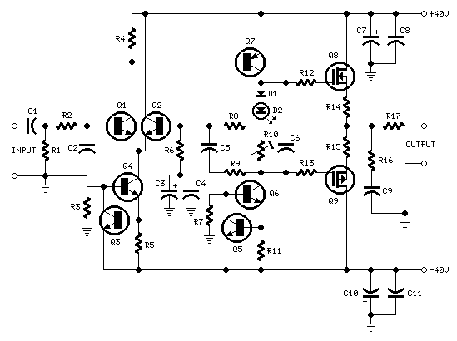
(source: eeweb.com/blog/circuit_projects)
- For the amplifier in the figure to the right
  - [4] Draw the small signal model labeling the small signal variables v_{i}, v_{o}, i_{o}, v_{d}
R_{D}
R_{S}
V_{o}
V_{i}

  - [1] Write an expression for G_{m} as the ratio of two small signal parameters while a third is held equal to zero.

  - [1] Write v_{d} in terms of i_{o}

  - [4] Write KCL @ v_{o} and solve for G_{m}.

  - [3] Find the approximate value for G_{m} for each of three different values of R_{D}: much less than r_{o}, equal to r_{o}, and much greater than r_{o}.

  - [2] Write the full expression for R_{o}. (you don’t need to derive it)

