EECS140 Final
Spring 2016
Prob. | Score
1+2 | /10
3 | /12
4 | /10
5 | /10
6 | /12
7 | /12
8 | /12
9 | /12
Total | /90
Name__________________________

SID___________________________

- [7] You purchased a power NMOSFET and want to verify the DC parameters on the datasheet: V_{t}, μ_{n}C_{ox}(W/L), and λ. Using two voltage sources and a current meter explain exactly what circuit setup you would use, what measurements you would take, and what calculations you would do. Assume that the device is quadratic.

- [3] Later you bias a similar device with the gate at 5V, the drain at 120V, and the source grounded. You measure a drain current of 1A. Increasing the gate voltage to 6V increases the current to 2A. With the gate still at 6V, you have to decrease the drain voltage to 20V in order to get the current to drop back to 1A. Near these bias points,
  - What is the transconductance g_{m}?

  - What is the output resistance r_{o}?

  - What is the intrinsic gain?
- [12] At t=0, the input voltage V_{i} below transitions from 0 to 2V. The capacitor starts with an initial voltage of 5V. μ_{n}C_{ox}=200μA/V², V_{t}=1V, W/L=10. Assume λ=0.

  - [1] What is the initial current in the MOSFET immediately after t=0?

  - [1] What is the initial rate of change of the capacitor voltage?

  - [1] How long does it take the capacitor voltage to decrease to 1V?

  - [1] What is R_{on} for the MOSFET in the triode region?

  - [2] How long does it take the voltage on the capacitor to decrease from 0.1V to 0.1mV?

  - [2] If C_{gd} of the MOSFET is 0.1 pF, and at t=t_{f} that is long compared to the times above the input voltage slowly transitions back to 0, what is the charge injected and the final voltage on the capacitor?

  - [4] Carefully sketch the capacitor voltage versus time, labeling each axis.
V_{i}
1pFF
t_{f}

- [10] In the circuit below, assume that V_{CM} = 0, and the op-amp is running from a single-sided 2V supply. Assume that Φ_{r} and Φ_{a} are non-overlapping clocks.
  - [1] during Φ_{r}, which switches S_{i} should be closed to ensure that there is no charge on the capacitors, and the op-amp is working normally in unity gain feedback?

  - [2] in Φ_{a} what is the feedback factor if switches S1, S4, and S6 are closed (and 2, 3, and 5 remain open)? What is the gain?

  - [1] If a settling accuracy of 0.1% is required with this switch setting, what is the minimum DC gain necessary for the op-amp?

  - [2] With this settling accuracy requirement, and Φ_{a} phase duration of 1μs, what is the minimum open-loop unity gain bandwidth of the op-amp?

  - [2] List all possible gains, if different switch settings are used.

  - [2] What op-amp topologies would work for this circuit? (list all viable combinations of simple single stage, two stage, FC, FC two stage, and NMOS or PMOS input)

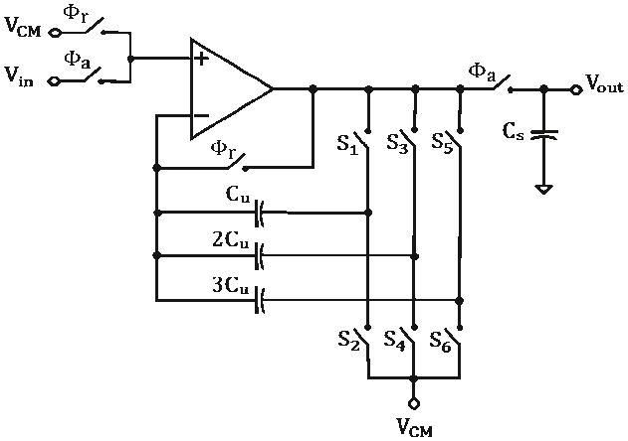
(Ragab, Kozak, Sun, IEEE TCAS 2013)
- [10] For the amplifier in the figure to the right
  - [2] Draw the small signal model labeling the small signal variables v_{i}, v_{o}, i_{o}, v_{s}
R_{S}
R_{D}
V_{o}
V_{i}

  - [1] Write an expression for G_{m} as the ratio of two small signal parameters while a third is held equal to zero.

  - [1] Given the condition above for the calculation of G_{m}, write v_{s} in terms of i_{o}

  - [2] Given the condition above for the calculation of G_{m}, write KCL @ v_{o} and solve for G_{m}.

  - [2] Find the approximate value for G_{m} for each of three different values of R_{S}: much less than 1/g_{m}, equal to 1/g_{m}, and much greater than 1/g_{m}.

  - [1] Write the full expression for R_{o}. (you don’t need to derive it)

  - [1] If R_{S} is much greater than 1/g_{m}, and R_{D}=2R_{S}, roughly what is the gain?
- [12] You have designed a two stage Miller-compensated op-amp with a phase margin of 45 degrees in unity gain feedback. The load capacitance is more than 10 times bigger than any other capacitor in the circuit. You have removed the RHP zero from the compensation capacitor.
  - [4] Carefully sketch a Bode plot of the open-loop gain. Assume that the DC gain is roughly 1000.

  - [2] If you increase the load capacitance by a factor of 10, what happens to the phase margin? Unity gain frequency?

  - [2] If instead you increase the compensation capacitor by 10x, what happens to the phase margin and unity gain frequency?

  - [2] If you increase both the load capacitance and the compensation capacitor by 10x, what happens to the phase margin and unity gain frequency?

  - [2] If you have a single-stage folded cascode op-amp with a unity-gain phase margin of 45 degrees and you increase the load capacitance by 10x, what happens to the phase margin and unity gain frequency?
- [12] In your project, you are having some trouble with leakage on the LD switch on the V_{ref} input. You decide that the best solution is to generate another regulated voltage, this one at 1.5V, to use for the gate and body of that PMOS switch.
  - [4] Using your bandgap reference of 1.2V, sketch the complete regulator circuit. Start at a high level, with an op-amp symbol, some resistors, etc.
  - [4] Discuss the topology for your op-amp, including input devices, what overdrive voltages you would pick, and why.
  - [2] Discuss the stability of the loop, and how you would guarantee it.
  - [2] Also show the circuit that you would use to convert the original LD signal running off of 1.2 V to the new LD_{1.5} signal at 1.5V.
- [12] Design an NMOS-input folded cascode op-amp with the following specs:
  - unity gain frequency of 1 Grad/s when driving a 200fF load
  - output swing to within 200mV of the rails
  - minimum channel length
  - minimum power, but with no overdrive less than 100mV
Process specs μ_{n}C_{ox}=200μA/V², μ_{p}C_{ox}=100μA/V², λ=L_{min}/(1V*L), -V_{tp}=V_{tn}=0.5V, V_{DD}=2V, L_{min}=0.1um, C_{ox}=10fF/um², C’_{ol}=0.3fF/um. You may use 1 resistor in your design.
Draw the schematic including bias circuits, label the device size of each transistor or transistor pair and the bias current flowing in each leg. Calculate the DC gain, the mirror pole/zero frequency, and the input capacitance.

- [12] In the following 2 bit ADC circuit, LD and CMP are non-overlapping clocks. Assume that the RC time constants are fast compared to the time scale below.
  - [10] Assuming V_{in}=0.2V, carefully sketch the waveforms on Vx and LOW on the graph provided below. V_{ref}=1V. b1 and b0 are either 0 or 1V.
  - [1] What binary value should the SAR report when V_{in}=0.2?

  - [1] If the comparator is implemented as an op-amp running from a supply voltage of V_{ref}, what topologies and input transistors can be used?

C₀
V_{ref}
+
-
LD
LD
CMP
LD
CMP
C₀
b₀
LD
CMP
2 C₀
b₁
V_{in}
V_{ref}
LOW
CMP
LD
b₁
b₀
0V
1V
V_{X}
LOW
2V
V_{X}

