Computer Science 160: User Interface Design and Development

Group Three: Interactive Prototype #1
October 26, 2001

Chris Kirschenman (cs160-ak)
Richard Hwang (cs160-ax)
Wayne Kao (cs160-al)
Hank C. Wu (cs160-av)

Prototype: http://24.7.202.244:8080/index2.htm
http://ratbert.bmrc.berkeley.edu/courseware/cs160/fall01/Projects/Group3/
Problem and Solution Overview

Researchers currently use a standard laboratory notebook and writing tool to log experiments and store their results. We propose that an electronic version of this notebook can offer many advantages over the current standard of tracking data on paper. We combine the notebook with relevant loose leaf pages that together comprise a researcher’s records, greatly improving organization, practicality, and efficiency. With electronic data, industry and research labs alike can enforce standardized formats so that biologists may exchange comprehensible data with each other. While researchers are comfortable with the current standard of pen and laboratory notebook, it is clear that improvement will be welcome. They frequently improvise to make their notes more readable, by cutting, pasting, and highlighting. For example, much time is spent creating Excel spreadsheets, photocopying, and pasting them into notebooks to provide generic and intelligible tables. With an electronic version of this notebook, we eliminate the unnecessary tasks that people repeatedly use to add structure and clarity to their notebooks, and provide convenient features that greatly reduce paperwork involved in research.

Biosk is based on the concept of integrating an entire biologist’s desktop into a simple to use and portable medium, served via the web so users can get a unified experience whether they are adding data through a PDA while they work on an experiment, or adding a research paper to their virtual notebook at home. Once in electronic format, the data becomes much easier to manipulate, allowing and encouraging sharing between researchers. Biosk aims to facilitate research by increasing productivity and communication capabilities among researchers. Ultimately, our users will be freed from having to do and redo tedious work on paper. They will be empowered through our integrated, centralized system, which allows them to achieve their tasks with maximum efficiency and focus on research.
Tasks

This section describes the tasks formed during our contextual inquiry, the same ones we asked users to perform during low-fidelity prototype testing for consistency. They are slightly expanded to test a few more aspects of our interface (e.g. larger spreadsheets) and to make our tasks more flexible (e.g. setting a task for today rather than for any specific date).

Task One: Create a new account, protocol, and its template (most difficult)

Here we would like the user to create a protocol in a notebook. A protocol is essentially a set of instruction for a particular experiment or procedure that will be used in the experiment. Sometimes, a template is also associated with the protocol to offer some structure and organization to what is required in the protocol. For this particular task, we would like the user to create a protocol and a table associated with that protocol.

We would like the user to create a new account with the username “bob” and the password “password1234” and then log in. From here on out, the rest of this task involves protocol(s). Researchers often have notebooks devoted to protocols that they have compiled and optimized over the years. Once logged in we would like the user to create a protocol for “Centrifuge @ 15000 g for 1 hr” in their account, and enter the following data. Once the protocol is entered, they should create a template the following data so that similar protocols can be created more quickly in the future.

Protocol:
Running the Gel
Gel: 1.5 % agarose gel

1080 dd water
120 10x TAE buffer

120 mL of the buffer will be used to make the gel.
Calculation of how much agarose to add: 120 * .015 = 1.8 g agarose

120 ml of buffer + agarose
then heat for 1 minute 20 seconds

Template:
dNTPs | Bb | Cc | Ee
ddH₂0 | 2 | 12 | 2
ddC0₂ | 32 | 1 | 22
ddCN- | 1 | 9 | 12

Detailed steps on how to perform this task:

● Enter notebook
● Enter protocol section
● Enter the steps that will be performed in the protocol
● Create a template for this protocol
● Enter the labels in the template for the protocol

Task Two: Create new experiment and enter notes (medium difficulty)

Experiments will make the backbone of the functionality of the notebook because on a day to day basis researchers write down notes on their results and plan out the future experiments according. Here we would like the user to create a new experiment entitled: “JS 1: PCR of Isolated SULT 1C1 in BAC D23 – First Attempt”.

In this case, JS 1 is a method on how to number and store the experiment (JS are the initials of the experimenter and 1 is the experiment #). Then the user should record general notes associated with this experiment:

Purpose: To determine if insert is correct size
Procedure:
Digest vector
Run digestion on gel
Determine size of cuts

Notes: To amplify the 5’ and 3’ ends of the isolated SULT 1C1 gene in the BAC D23 clones. The FLS primers have been constructed to hybridize to a specific sequence on the gene in the BAC DNA - if we get a positive band, then the sequence at the 3’ end we’re looking for is on the vector.

Detailed steps on how to perform this task:

● Enter the notebook (where you will be on a page)
● Create a new experiment by writing in a new title and number for the experiment

JS 1: PCR of Isolated SULT 1C1 in BAC D23 – First Attempt

● Enter some information into your lab notebook regarding your new experiment:

Task Three: Create a reminder (least difficult)

This will be a particularly useful function for researchers because they must keep track of multiple experiments and tasks throughout each day, week, month and so forth. Thus it would definitely help researchers if they were able to set up reminders for later so that they do not have to remember it or write it down on a piece of paper that can easily be lost. For this task, we ask the user to set a reminder to do something in the future. For this particular task we would like them to set a reminder for: “check progeny” today.

Detailed steps on how to perform this task:

● Enter notebook
● Write down a reminder for self
Check progeny today
Set reminder to signal this message with a reference to date, experiment #, experimental name, today
Revised Interface Design

Differences as a Result of Low-Fidelity Testing and Why

Our low-fidelity prototype report contained a list of problems users encountered, which we addressed in the high-fidelity prototype. We have annotated that list as well as expand on it we worked through the prototype. The following describes each issue, how we have addressed it, or why we have decided to disregard it.

● Include identifying location: All pages in Biosk now have a color which is associated with a tab at the top of each page. By quickly looking at the color of the page and the corresponding tab, a user can determine his location in Biosk without effort. (Figure 1)
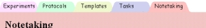
Figure 1

● Text boxes need to be labeled more clearly: All text boxes now have a clear label to their left. Forms have been neatly organized into tables for clarity and ease of use. (Figure 2)  ● Buttons need to be labeled more clearly: Incorrect and ambiguous labels have been revised on all buttons. | 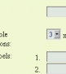  Figure 2
● Add ok button to confirmation messages: Due to user complaint about persistent confirmation messages, Biosk now has transient confirmations that stay on the screen a short while before redirecting to the next page in the sequence. (Figures 20 & 21)

● Add cancel buttons to allow backward movement: Cancel buttons have been added to all major forms. They send the user back to the first page within the section (i.e. the page that would load were the user to click on the corresponding tab). (Figure 3)  ● Add view and edit on experiments page – These options were added. | 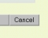  Figure 3
● Add ability to reference protocol by clicking and bringing it up on the side / Add ability to view notes on New Experiment page / Add ability to see the whole notebook: After much discussion, it was determined these would unnecessarily clutter the pages and make navigation confusing by introducing too many tabs. The user can get all this functionality by simply opening two browser windows.

● Clarify note taking page / Identify information on left column in note taking page / Fix save and continue writing button in notes/protocols: The buttons on the bottom of the note taking section were relabeled, and the protocols/recipes viewer on the left was named Quick Viewer for clarity. (Figure 22)

● Add ability to change/edit reminders / Add ability to change/edit notes: Edit buttons were added to these pages.

● Need Help section: The help system was delayed for this iteration. This decision is described in detail in the What Was Left Out section below.

● Allow right column to go away or appear with different information: In response to user comments that the right column of pages was often empty, we distributed functions and buttons evenly between the two columns. (Figure 4)  ● Options / Add section to change settings: The user who mentioned this provided it as a mere suggestion, because they could not think of any options they would want to change. Rather than build a separate options page, we chose to incorporate several options in each of our forms.  ● Try to minimize pages with only single login: Biosk has been implemented with session-based logins. The users can login once, and the system will remember usernames and passwords until they log out. | 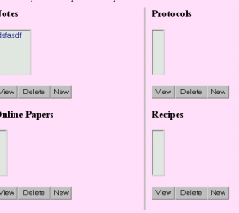  Figure 4

● Add Logout: This was added to the right of the tabs. (Figure 5)  ● Clarify what date means on task menu: All “Date” occurrences in the Tasks section of Biosk were relabeled to “Due Date” to make the reference clearer. |  | 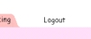  Figure 5
● Fix resize button: For Templates and Protocols, resize selection was redesigned using JavaScript. By making a size change instantaneously instead of forcing the user to click “Resize”, resizing is now more intuitive. (Figure 6)  ● Moved tabs: Although we designed the tabs to be the main means of navigating Biosk, almost none of our users used them in our user tests. To make the tabs more obvious, they have been moved from the right column to the top of the page. | 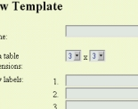  Figure 6

Scenarios for Three Tasks (Storyboards)

● Task One: Create a new account, protocol, and its template (most difficult)
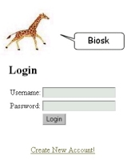  Figure 7  1.The user starts from the log-in page. They do not have an account and part of the task involves creating a new one, they click the “Create New Account!” link at the bottom of the page. | 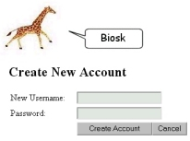  Figure 8  2. Following instructions, the user enters the username “bob” and the password “password1234”, and then clicks on the “Create Account” button.
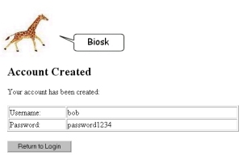  Figure 9  3. A confirmation message appears and reports account has been successfully created. User then clicks the “Return to Login” button. | 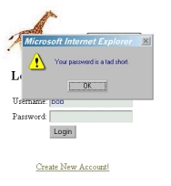  Figure 10  4. Back at the login page, the user enters the username and password they just registered. If an error is made in entry, an error message appears. Eventually, the user logs in by entering bob/password1234 correctly.

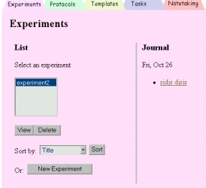  Figure 11  5. Logged into Biosk, the user is led into the Experiments section by default. Because the task is to create a template, the user clicks the “Template” tab at the top of the page. | 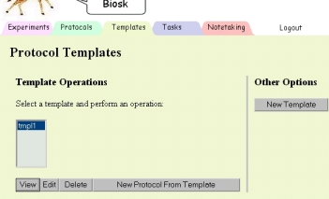  Figure 12  6.To create a new template, the user clicks the “New Template” button in the right column.
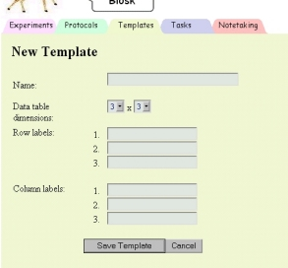  Figure 13  7. Following instructions, the user gives the template a name, and selects a 3x3 table for three rows and three columns of data. After row and column headings are entered, the user clicks “Save Template” and submits the information. | 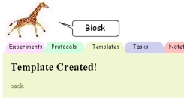  Figure 14  Figure 15  8.The user gets a confirmation message that reports the template has been created. It automatically redirects back to the Protocol Templates page. Since the next part of the task involves creating a protocol from the template, he highlights the template just created, and clicks “New Protocol From Template.”
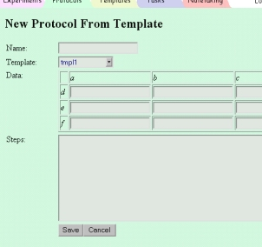  Figure 16  9.Here, the user could change his template to any template, but the one he chose on the previous “Protocol Templates” page is already pre-selected, with the axis labels filled in. He gives the template a name, enters the data, and fills out the steps. Finally, the user clicks “Save”. | 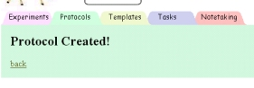  Figure 17  10. The user gets a confirmation message, reporting the protocol has been successfully created.

● Task Two: Create new experiment and enter notes (medium difficulty)
Figure 18  1.While logged in, the user clicks the “Experiments” tab on the top of the page. If the user is logging in just now, the “Experiments” page is the default page. Because the task is to create a new experiment, the user clicks the “New Experiment” button at the bottom of the left column. | 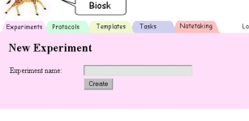  Figure 19  2.This screen simply asks for the name of the next experiment, given as “JS 1: PCR of Isolated SULT 1C1 in BAC D23 – First Attempt” in the instructions. The user enters the title and clicks the “Create” button to create the experiment.
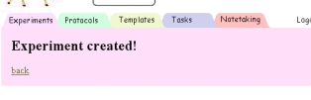  Figure 20  Figure 21  3.The user gets a confirmation message reporting that the experiment has been successfully created, and gets redirected back to the “Experiments” page automatically. Because a note needs to be entered, the user clicks on the “Notetaking” tab at the top of the page. | 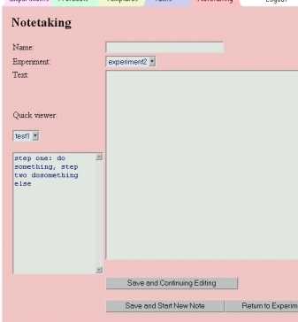  Figure 22  4.The user enters the name of the notes in the text box on top, selects “JS 1: PCR of Isolated SULT 1C1 in BAC D23 – First Attempt” as the experiment, and enters the notes given. The user then clicks either “Save and Continuing Editing” or “Save and Start New Note”.

● Task Three: Create a reminder (least difficult)
Figure 23  1.From any page while logged in, the user clicks the “Tasks” tab on top. We’re showing the “Experiments” page here because it’s the default page shown after logging in, but any page while logged in can be substituted. | 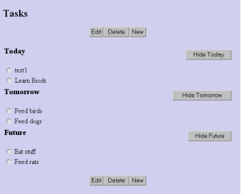  Figure 24  2. Because the goal is to create a new reminder, the user clicks the “New” button from the main tasks page.
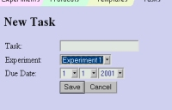  Figure 25  3.The user enters “progeny” as the name of the reminder as requested in the instructions, selects an experiment from the pull-down menu, and chooses today’s date as the due date. The user then clicks “Save”. | 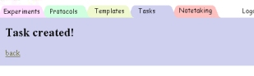  Figure 26  4. The user receives a confirmation message reporting the task has been created.

Prototype Overview

Tools Used

Front-end tools:

● FrontPage: Microsoft FrontPage is great for creating pages and forms. It was very useful in drafting pages so we could quickly determine whether a certain page envisioned in the low-fidelity prototype can become a feasible implementation. Wayne especially liked the ability to switch from WYSIWYG to HTML mode. This made it so he could use FrontPage wizards to make some parts of the page, and directly edit code when he couldn't figure out how to accomplish something with FrontPage’s options. FrontPage also had a preview mode, essentially an embedded Internet Explorer renderer which made it very easy to tell how our pages would look.

● Dreamweaver: Macromedia’s Dreamweaver has an excellent template system which allowed us to create a template for what a general page would look like, and then easily replicate it for all the pages in our site. Most importantly, if we wanted to make a global change, we only had to change the template and Dreamweaver would make sure the changes propagated to all the relevant pages. Dreamweaver was really bad for actually laying out pages and forms, and for writing code. It was also very un-user-friendly. When Wayne tried to edit code directly, lots of unexpected errors would occur. It was also ambiguous how to do something simple, like adding a text field, for instance. Dreamweaver made certain assumptions, which it didn't make clear. For example, pages need to be grouped by site, which they called a "web." There is no way to know this intuitively without consulting help.

Back-end tools:

● JavaScript: We seriously considered implementing the entire prototype in HTML/JavaScript. We would have been able to show all the important screens, simulate feedback to user actions (e.g. pop up a window when a button is pushed), and the users would have been able to complete all the tasks. Most importantly from our perspective, using JavaScript requires no backend programming, no actual servers, and just a little client-side scripting. Unfortunately, with JavaScript we would have to anticipate every possible user action and create a page for every possible place that the user might visit. That would have required generating an exponential number of pages if we wanted to have all the important pages on-hand. In the end, though we did use some JavaScript for delete confirmation windows, we decided to use Java servlets for most of the dynamic elements of Biosk.

● Apache Tomcat Server/Java Servlets: We ended up siding toward servlets so we wouldn't have to use as many Wizard of Oz techniques, and so the user wouldn't get confused if they strayed too far from how we, as the designers, thought they would perform the tasks. There might be alternative ways of accomplishing the tasks that we didn't anticipate, and we want to give the user the opportunity to do that.

• XMLC: XMLC is a tool that converts HTML into Java code using special "tagged" fields to designate dynamic data. This was used so that changes to the interface would not affect the underlying foundations. This worked well with allowing minor changes to the interface without requiring a major modification of back-end Java code. For example, when we added the tabs to the top of our screen, all that was required was a simple recompile. No backend changes were necessary. This tool did not help when we had to make major changes such as changing a text box into a pull down menu. This broke the abstraction by requiring changes to the Java code.

● MySQL: We used an actual database (MySQL) instead of simulating one in code. This was done so we could maintain state across several different sessions, making it easier to implementing and giving a consistent experience to the user.

Overview of the User Interface Implemented

The overview has changed little from our low-fidelity prototype. We have tried to convert as much of the low-fidelity as possible into the high-fidelity prototype, focusing first on sections in Biosk that are used in our three tasks.

The central part of our interface is our tabbed navigation area. In order to encourage the user to get comfortable quickly with the interface, we kept a consistent and neat look throughout the pages. While the user is logged in, we have a series of tabs along the top of every page, one for each major section of Biosk. This is the part of Biosk that remains constant, ensuring that the user would never have a problem quickly getting to another area.

Here is a brief description of each major section of the site, each represented by a tab in Biosk:

● The experiment page is the default page users see when they first log in to Biosk. We split this page into two relevant sections. One contains a textbox of experiments, where users can select any of the experiments and view or delete them. They can also sort the list by title or date, as well as add a new experiment. On the right hand side of the page is a journal that logs recent experiments. The view page is a kind of portal page grouping together the many aspects of an experiment including recipes, protocols, and research papers.

● The protocol and protocol template sections allow the user to store biological data in an interesting (optional) grid structure. They first set up the row and column labels, then they could enter values into the produced grid.

● The notes page is essentially a large text box. It was created with the goal of making it very easy to enter massive quantities of data quickly, just like one might do on a piece of paper.

● Finally, the task page features optional filtering by day selection, so the user can choose tasks from today, tomorrow, or future (beyond tomorrow). For example, the user can specify they are only interested in tasks for the next couple of days by hiding the future tasks.

What Was Left Out And Why

High-fidelity versus Low-fidelity

During our low-fidelity prototyping, we designed the prototype based on what we thought we would be able to do in terms of a web-based application. Thus our high-fidelity prototype incorporates basically all of the features that we had in our low-fidelity. However, in moving from the original project proposal to our low-fidelity (and high-fidelity), we did leave out several ideas in terms of functionality because implementing those functions would prove to be either far too difficult or time consuming to implement in the time allotted.

Initially we wanted to keep this very much like a notebook where a touch screen and an electronic pen can be used to jot down simple notes and figures directly (much like a PDA). Unfortunately, incorporating this particular feature into our web-based kiosk would be an enormous project in itself. It was left out so we can focus on the graphical user interface. However, we may later add a dummy page that can represent these possibilities with direct input.

Another idea was the ability to reference protocols within the notebook. For example, say a user is in the middle of jotting down notes and writes down that they’re using “X protocol”, they could mark the text “X protocol” by right clicking (or something similar) to designate it as special text with a link to a protocol stored elsewhere in Biosk. This is extremely difficult to show, even as a demonstration, so it has been delayed until further notice.

We also had in mind a type of text search so that the user could search through their notebook for keywords or phrases. We still hope to do this, but did not have enough time to implement this particular feature in the high-fidelity prototype.

We left out most of the error checking at this stage. We would prefer to observe our users interact with the software so that we can recognize whether the problem is something that should be resolved through additional code or through changes in the interface. We have also left out a few of the confirmations that were not associated with any of our tasks. They are on our to-do list for a later revision. We were planning a very substantial help system, one that could change context depending on where the user is in the page, but we weren’t able to acceptably implement it in this iteration due to coding difficulties. We decided to delay the help system until we could properly implement it. There were a few areas where we ended up hard coding because it was not really relevant at this stage, a couple of examples of this were the journal entries and the protocols/templates on the note taking page. One last thing we did not implement in this iteration was a user’s suggestion that we add another tab for recipes.

Web-based Kiosk versus Personal Display Device

Although there are obvious advantages to having a portable system available, there are several reasons why we chose to implement our prototype as a web application targeted at a personal computer rather than creating a personal display device (PDA) application:

● Computer kiosks have bigger screens which lets the user display more information than they could using a PDA.
● Researchers might want to access their work at home remotely on a computer which wouldn't be possible with a PDA.
● Biology researchers mainly work indoors where networked computers are in abundance. The vast majority of biology laboratories are not equipped with PDAs.
● Web services are easier to maintain while updating software on a PDA requires manually making changes on each PDA. Although this is not a user-interface issue, it is an important issue that would be considered if Biosk was actually implemented.
● Even though our target platform is a kiosk like the Clio, we have not tested our high-fidelity prototype against the Clio for compatibility. This is because at this stage we are focused on setting up a working version of Biosk to examine functionality and aesthetic issues.

Last-Minute Considerations

● Change username and password from “bob” and “password1234” to work for any input.
● Add help button even though help system is not functional. This way we can see how it fits in the interface.
● Improve confirmation system. Think about implicit confirmations, such as embedded messages or showing the template or protocol just created.
● Fix construction of data tables. Though we designed Biosk so that it closely resembles how an actual lab notebook works, it is clear that the table construction page can be improved. Miriam suggested a page where row and column headings could be entered, without redundantly asking for number of rows and columns. This can be done with a box for row headings and a box for column headings, and an “add” button where presets as well as new headings can be entered. A dynamic table preview on the side would complete the picture.
● Experiments can be sorted by date, but the list of experiments do not contain a column for date created. Add such columns so that such information as date created or date last modified are visible.

Wizard of Oz Techniques Required To Make It Work

We tried to minimize our reliance on wizard of oz techniques at this stage. However, we still have a few things which only appear to be functional such as the journal entries and buttons that are not used in any of our tasks (e.g. show/hide buttons on the task page). We made the decision to fake things as little as possible at this stage, so the users will feel more comfortable testing when they notice persistent in their data entries.
Prototype Screen Dumps

Here are other sections of our interface we implemented that have not been addressed above.
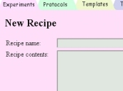  Figure 27  The recipe add page has a blank to enter a recipe name and the contents of the recipe. The recipe contents is just a large text blank to give users freedom in how they wish to format their recipes. | 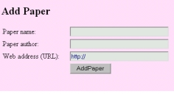  Figure 28  Research publications found on the Internet can be associated with experiments. This figure shows how the paper is initially added to Biosk
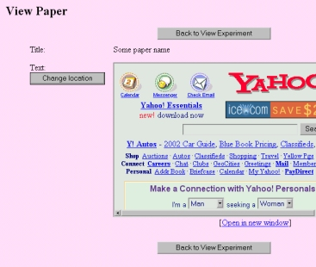  Figure 29  Papers can either be viewed within Biosk, or opened in a separate window. | 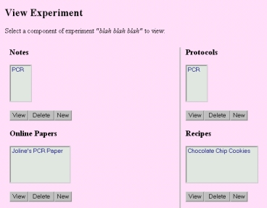  Figure 30  Notes, protocols, online papers, and recipes are all associated with experiments. The “View Experiment” page lists everything associated with a particular experiment.

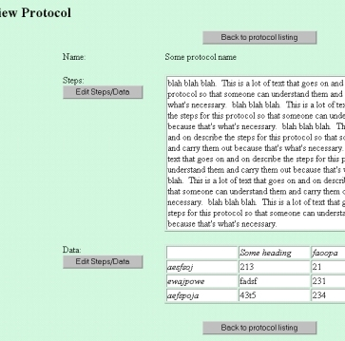  Figure 31  Our tasks involve creating a task, but not viewing them. The “View Protocol” operation lets the user see data he has entered. All critical text is colored black and placed on a white background for maximum, paper-like contrast. Buttons let the user quickly switch to edit mode in case he spots an error. | 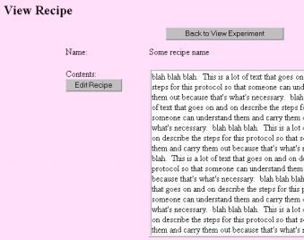  Figure 32  The functions that allow for recipe recipes viewing are very similar to those which let you view protocols.

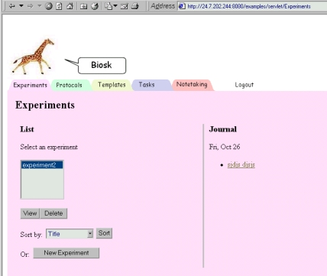
Figure 33

This screenshot of the “Experiments” page shows a full typical Biosk page. This figure was included since only partial screen captures of most Biosk pages are included above.
Prototype Information (aka the README)

Our prototype can be found on the web at: http://24.7.202.244:8080/index2.htm

Usage notes:
● This server is not a server, but one of the group members’ personal computer. As such, it is not 100% stable and there may be occasional downtimes.
● If you use Microsoft Internet Explorer to access the prototype, make sure to include the http:// in the URL above. Internet Explorer has a problem whereby the http:// is not entered before an alternate port (i.e. 8080), it won't load.

