Art, Math, Science, and Computers

Carlo H. Séquin
CS Division, University of California, Berkeley
E-mail: sequin@cs.berkeley.edu

Abstract
This article discusses and illustrates the beneficial symbiosis between art, math, science, and computers. Mathematical thinking, computer programs, and interactive CAD environments make it possible to gain a deeper understanding of existing artwork and to extract generating paradigms that can produce additional art pieces of the same type. Conversely, well-crafted visualization models for purely mathematical concepts can lead to geometrical shapes in two or three dimensions that can be considered works of art in their own right.

- Introduction
This article is prompted by the upcoming international conference of Bridges Seoul 2014: Mathematical Connections in Art, Music, and Science, which will be held concurrently with Seoul ICM 2014. Since 1998, the Bridges Conferences [7] have explored and celebrated the connections of mathematics to art, music, science, and to many other facets of culture, including architecture, dance, poetry, basketry, and origami. Here it is not my intention to provide a review of this vast and diverse field; this would require a whole monograph, such as those by Peterson [19], Emmer [9], and others. Instead I will focus on a subdomain in which I have three decades of personal experience: the generation of abstract geometrical sculpture and mathematical visualization models. In the first Bridges conference in 1998 I presented a paper entitled “Art, Math, and Computers: New Ways of Creating Pleasing Shapes” [24]. Here I would like to revisit the subject matter of that paper in the light of fifteen years of progress. As will be shown, in this particular subdomain computers have gained significantly in importance.
But I would like to start with a broader perspective on the relationships between math, science and art. In 2006, Dr. Ivan Sutherland ‒ by many considered to be the godfather of computer graphics ‒ asked me an intriguing question: “What came first: Art or Mathematics?” I think the answer to that question is fairly clear. There is much evidence of artistic artifacts dating back 25,000 years and more, such as the cave paintings near Lascaux, or the small statuette Venus von Willendorf (Figure 1a). No mathematics is needed to create or to understand these works of art. Mathematics, especially fractions and geometry, started to play a role when humans tried to fit regular periodic patterns around a basket or a vase (Figure 1b), or around a column or cupola; it helped to place n elements evenly in a circle or around a cylinder. Purely math-based algorithms and computers were used towards the end of the last century to display Julia sets or the Mandelbrot fractal (Figure 1c). With the emergence of 3D printers and rapid prototyping machines based on layered manufacturing, it became possible to create small sculptural maquettes even for occasional artists with less developed manual skills (Figure 1d).
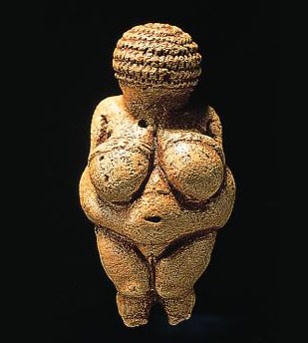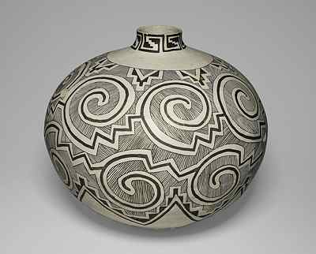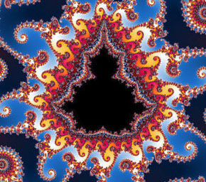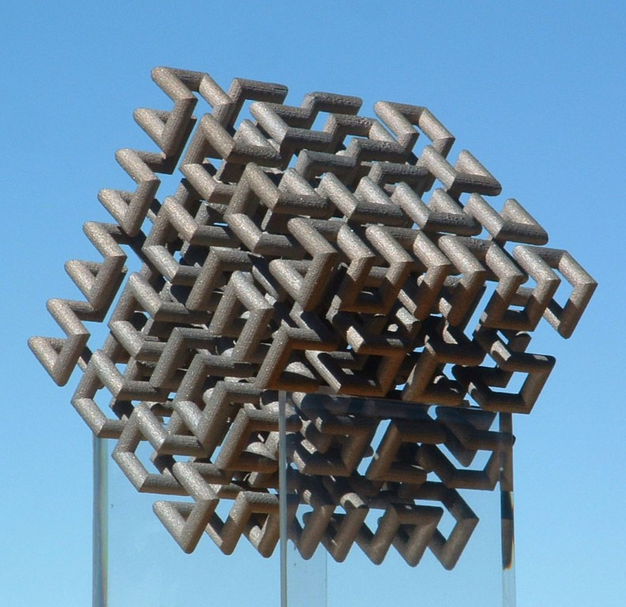
(a) (b) (c) (d)
Figure 1: (a) Venus von Willendorf (23,000 BC), (b) Anasazi olla (ca.1200 AD), (c) Mandelbrot fractal (1980), (d) Hilbert-Cube_512 (Séquin, 2006).
Now I would like also to ask a different question: “What came first: Art or Science?” To arrive at justifiable answers, we first may want to ponder questions such as: “What is art?”, “What do artists do?”, “What is science?”, and “What do scientists do?”.
A good way to describe scientists is to define them as model-builders. They carefully observe the domain of their interest and then try to capture their findings in a predictive model. The quality of their work is judged by how succinctly their proposed models capture all their observations and by how accurately those models can predict reactions and consequences of changing some of the inputs or constraints on the systems being modeled. Over time, models may be refined and extended to cover a larger domain of application, just as Newton’s model of gravity and planetary motions got enhanced by Einstein’s theory of general relativity.
Artists may also start with acute observation of the world around them, and then render what they see in their own way, in many possible media, perhaps emphasizing what seems important to them. They may also change their depiction in order to send a specific message to the intended audience, or to portray their personal vision of how they would like the world to be. In this mode, artists are not very different from scientists: they start with some observations and then produce abstracted renderings of what they have perceived. Thus, perhaps, art and science have the same common origin in detailed observation of one’s surroundings and documentation of those findings.
Alternatively, artists may (perhaps playfully) combine simple elements in a constructivist manner into more complex configurations, without trying to reproduce any particular observations. They might assemble elementary geometrical shapes into complex structures, or combine a few musical themes into prolonged chants or into sophisticated orchestral pieces. In either mode, artists create models or structures that are supposed to capture the attention of some observers, and hopefully draw them into some kind of dialog. Judging the quality of these artifacts is, however, much more subjective and highly dependent on the cultural context, which may vary strongly with time.
In the last few centuries, telescopes, microscopes, and many other tools for observing nature at different scales have vastly expanded the domain of what can be observed, and thus provided exponentially growing stimuli for making new scientific models and new artistic artifacts. Most recently, computers provided amplification for both art and science. They enhanced many of the observational tools and helped to construct new models with vastly increased complexity and sophistication. Simulations of all kinds became possible, enhancing the understanding of the derived models and validating or falsifying them. Mathematical analysis helps to uncover hidden structure in complex systems, and mathematical thinking leads to more structurally defined pieces of artwork for artists who are willing to embrace the new tools.
There are many cultural domains in which some form of mathematical thinking played an important role long before any computing machines existed. We find obvious rule-based thinking involving the iteration of patterns and their transformation through inversion, rotations, or other symmetry operations, in architecture, music, dance, origami, basketry, weaving, tiling patterns, the visual arts, and in the structure of balladry or theatrical plays. Some examples are shown in Figure 2.
Even in domains where long traditions have prevailed or ground-breaking work was generated before the advent of any computing devices, today’s artists and researchers will now frequently use the assistance of electronic computers in the discovery of the underlying patterns in existing artwork, in explanatory reproductions of such work, or in the generation of new artifacts obeying previously used rules and patterns. Very few people today would draw Islamic (Figure 2a) or Escher-style tiling patterns by hand without the use of computer graphics! But there may always exist a few artists with extraordinary craftsmanship who will create amazing artwork entirely without the use of computers, because they love the non-computerized tools and the direct hands-on process – just like some people prefer to write their letters or poems with a pen, no matter how convenient and how sophisticated word-processing tools will become. But even these artists may use a computer to analyze or study tentative patterns before creating their own hand-made artworks.

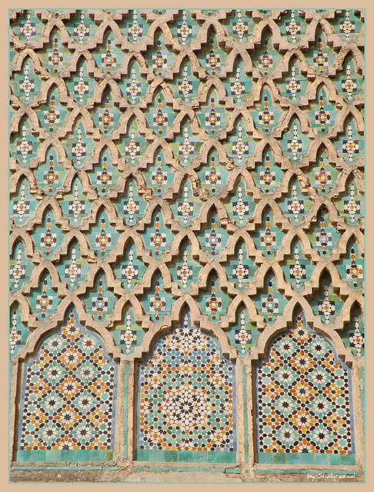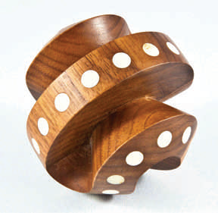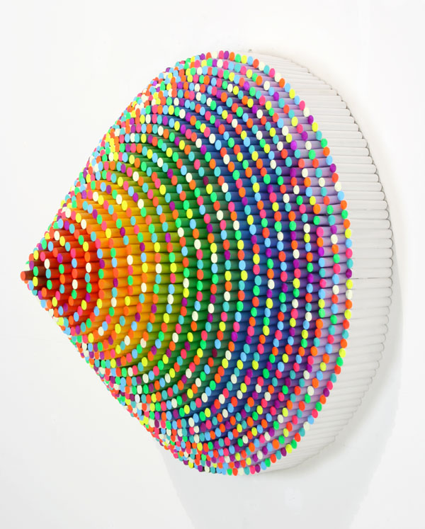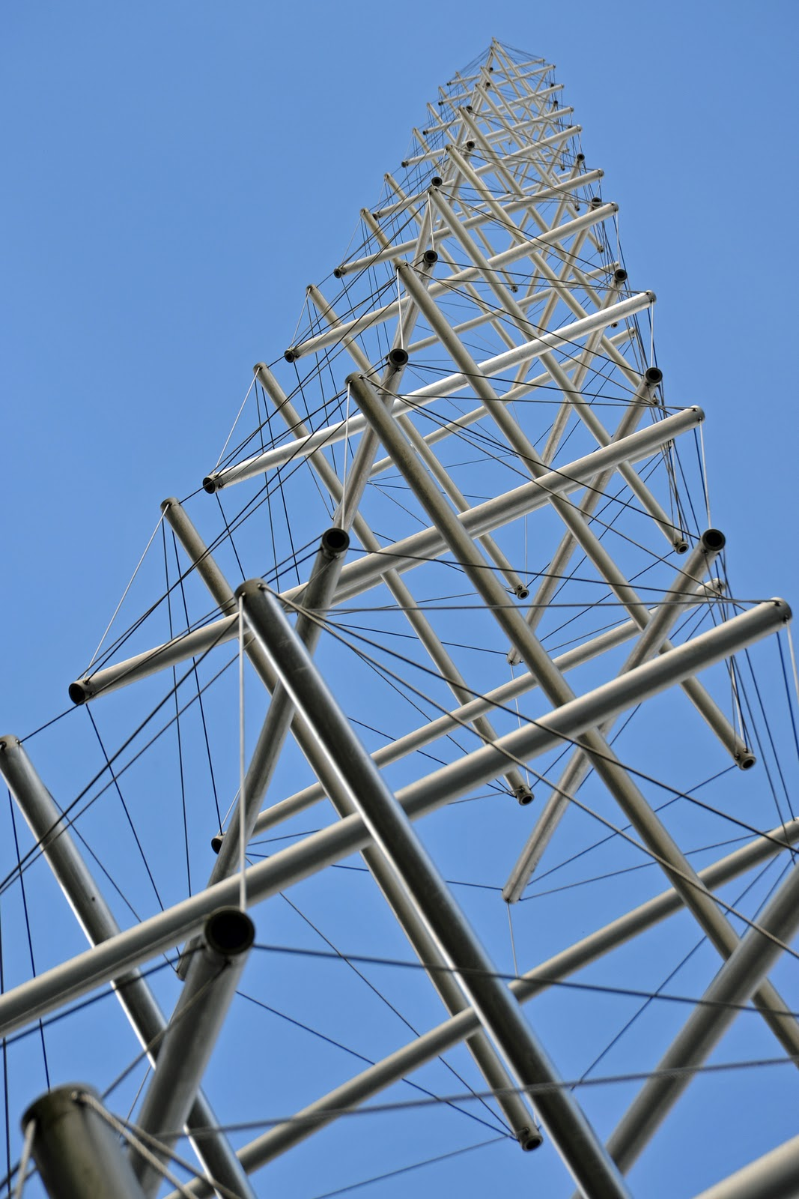
Figure 2: Art-Math objects created without the use of a computer: (a) Moroccan screen [3],
(b) Ambigram (Kim [14]); (c) Wood turning (Rollings [21]); (d) Dowel construction (Stark [30]); (e)Tensegrity tower (Snelson [29]).

- Recent Developments in Computer-Aided Design
Since 1998, affordable computing power has continued its exponential growth. This now allows us to perform computations on a hand-held device that 16 years ago would have been tasks for a super computer. The key beneficiaries in the context of our discussion are computer graphics, simulation, learning algorithms, and optimization. Virtual renderings of arbitrarily complex sculptures can now be done with full photo-realism, and real-time interaction with complex scenes offer us fast-paced, dynamic video games. On the other hand, fully immersive virtual environments are still at the frontier of research. The required light-weight, wide-angle, high-resolution, head-mounted displays with rock-stable head tracking are still not available. The much expected progress of haptic interfaces, which provide feedback to the user via the sense of touch, is even more disappointing. Thus the options for displaying art in a convincing, enjoyable way in virtual form fall considerably short of my expectations of fifteen years ago.
On the other hand, the ability to produce tangible, physical output of almost any arbitrary shape has undergone an unexpected revolution. Rapid prototyping machines based on layered manufacturing, which used to cost several tens of thousands of dollars, are now available for as little as a few hundred dollars at the low end. And at the high end their speed and accuracy has improved dramatically. The range of available output materials has also increased, ranging from selectively held-together, colorful powder used in 3D printers, to many stiff or flexible plastic parts, to ceramic and metal parts, and including even ways of making transparent geometry of almost optical quality [11]. Artists and designers are no longer restricted to construct artifacts from just a single homogeneous part. Their creations can now include moving hinges and sliding joints, input sensors and actuators, electronics components, and visual output delivered by LEDs and suitably curved fiber optics. The basic approach of layered manufacturing has also been extended to include the selective deposition of concrete over areas several square meters in size.
Both these developments favor the use of computers and an algorithmic approach to creating designs and realizing them physically. With the current state of affairs, the use of computers will favor a two-phase approach for the creation of art work, where there is a clear conceptual design phase, followed by a detailed optimization phase that is closely tied to the specific way in which a particular artwork will be realized. Completely interactive, free-form design and modeling tools, such as Virtual Clay [17] still lag significantly behind the expected development curve. The transition from a vague idea, existing only in one’s head, to a first concrete model in a computer is still the weakest link in today’s suite of commercially available computer-aided design (CAD) tools.

- A Successful Design Process
Most of my artistic designs during the last two decades have followed the same generic pattern outlined in Figure 3. An inspiring artifact, found in nature, seen on the Web, or created by an artist, excites me enough so that I want to make other shapes that look somewhat like it, but where I could experiment with making some continuous or discrete changes.

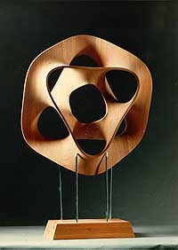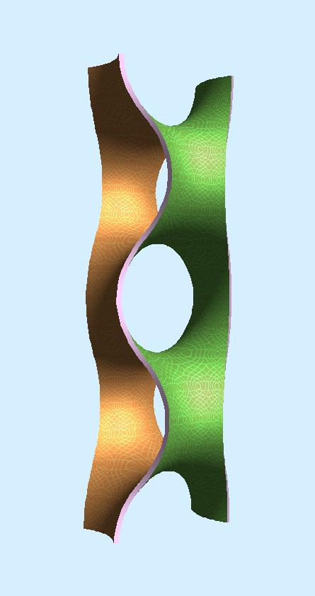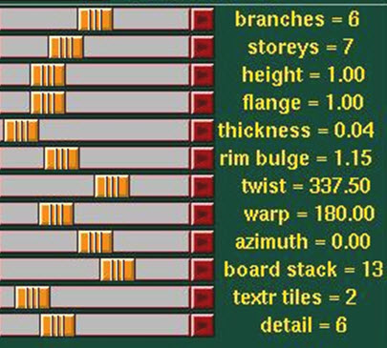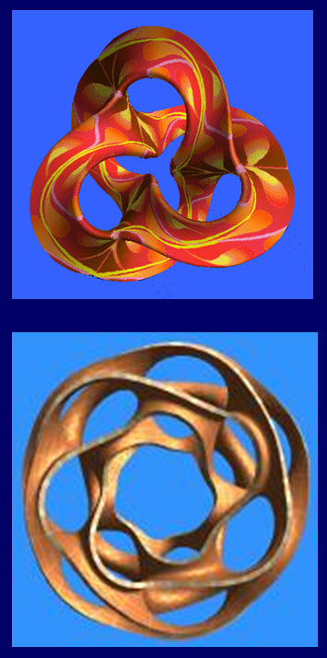
(a) (b) (c) (d)
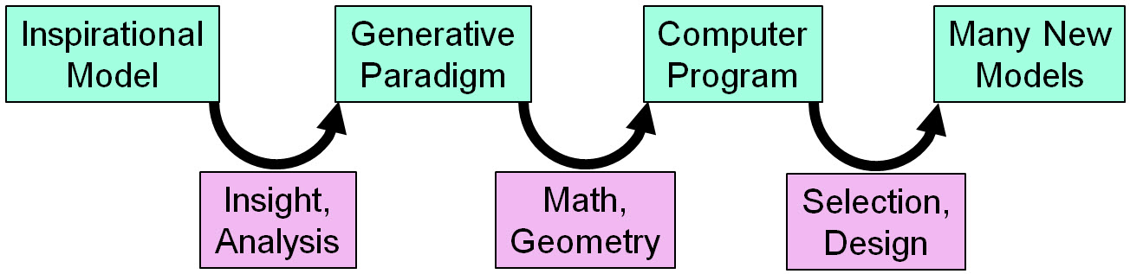
Figure 3: Process of creating new sculptures inspired by an original artwork: (a) Hyperbolic Hexagon by B. Collins, (b) Scherk Tower, (c) controls in “Sculpture Generator 1”, (d) two new shapes.

The Hyperbolic Hexagon (Figure 3a) carved by Brent Collins [8], an American wood sculptor, served as such an inspirational starting point. The key step consisted in identifying a generative paradigm that could re-create this shape ‒ and many other ones that somehow “belong into the same family.” The crucial insight came from George Francis [10] who had previously analyzed Brent Collins’ work and noticed that the geometry of Figure 3a could be described as a chain of six saddles cut out of the central portion of Scherk’s Second Minimal Surface (Figure 3b) [22], which are then wound up into a closed circular loop. Clearly, by selecting a different number of saddles, changing the aspect ratio of the tunnels, varying the width and thickness of the flanges, and perhaps imparting a longitudinal twist upon the Scherk tower before it is closed into a loop, can lead to similar but different toroidal geometries. This prompted me to write a narrowly focused, custom-made program [23] that could generated these shapes under the control of about a dozen parameters (Figure 3c). This involved a modest amount of mathematics and geometry. A single saddle was defined as a set of triangle strips following a set of hyperbolic curves, which all had their “heads” on an ellipse that defined the tunnel opening in the Scherk tower. This prototypical saddle was then iterated along the z-axis as often as specified by the parameter “storeys”, and the whole assembly was twisted around the z-axis as specified by the “twist” parameter. Another global transformation then bent the Scherk tower into an arch or warped it into a closed loop. Playing with these parameters in a real-time display environment allowed me to generate a wide variety of shapes in a matter of minutes, two of which are shown in Figure 3d. At this point, the “artist’s” contribution consists in making a judicious selection of parameter values that result in a pleasing overall shape. Novice users of the program often tend to go for too much complexity by pushing several sliders towards their high ends, thereby creating structures that look more like cooling coils in a power plant rather than aesthetically pleasing geometrical sculptures.
A similar process was also used for sculptures in which a single ribbon winds around a sphere or forms a mathematical knot. In this case the inspirational model that started the process was Pax Mundi, another wood sculpture by Brent Collins (Figure 4a). The extracted paradigm was a sweep of a crescent-like cross section along a 3D space curve closely hugging an invisible sphere. This notion was then captured in a modular way within the Berkeley SLIDE modeling and rendering environment [28]. In this Viae Globi generator (Roads on a Sphere), there are three separate banks of parameter sliders: They control the path of the sweep curve on the sphere, the shape of the cross section, and the orientation, twisting, and scaling of the cross section as it moves along the space curve. This was sufficient to capture the geometry of Pax Mundi (Figure 4b) and to redesign it at a larger scale for a bronze sculpture located at the H&R Block headquarters in Kansas City (Figure 4c). Later the program was extended to handle more general space curves, so that it could also help in the re-design and scaling-up of another sculptural model by Brent Collins, Music of the Spheres. The resulting bronze sculpture (Figure 4d) is now located at Missouri Western State University.
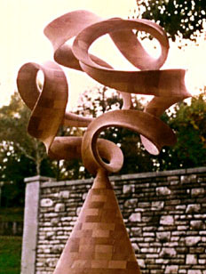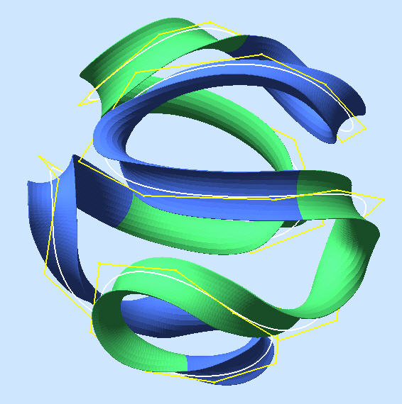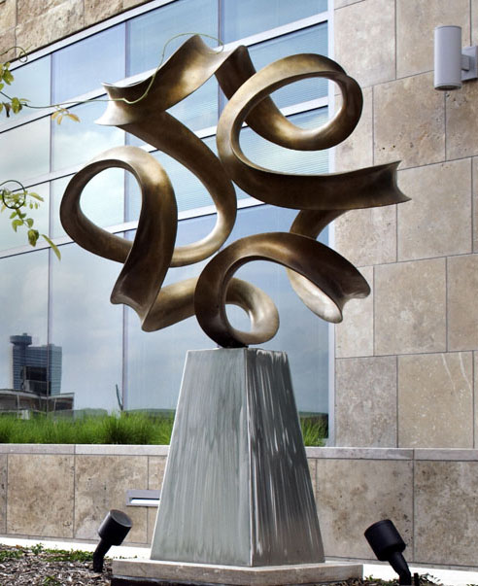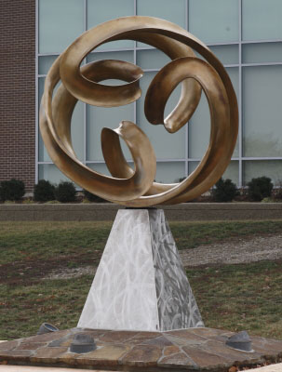
(a) (b) (c) (d)
Figure 4: Ribbon sculptures from the Viae Globi series: (a) original Pax Mundi by Brent Collins (1997) (b) paradigm captured in SLIDE; (c) bronze sculpture (2007); (d) Music of the Spheres (2012).

- Capturing Arbitrary Designs
The design process for any physical artifact rarely starts in a vacuum. Often there is a previous version of the same object that needs to be improved in some specific way. Unfortunately, the original design files are often unavailable, and all that a re-designer has access to is the artifact itself (the geometry of which could be captured with a 3D scanner) or perhaps an unstructured, hierarchically flat CAD file, consisting of tens of thousands of triangles. These are bad starting points for high-level design modifications, as the positions of thousands of vertices would have to be changed simultaneously in a coordinated manner. What we would rather like to have is a modular, parameterized, procedural description in terms of sweeps, quadric surfaces, constructive solids geometry (CSG) primitives, and other geometrical elements that are readily used in CAD programs.
Recent research by James Andrews has resulted in a demonstration program for a User-Guided Inverse 3D Modeling approach [2] that can produce such desirable descriptions form overly detailed input such as a 3D scan. Guided by some high-level, interactive, graphical user commands, the program will approximate pieces of the given input geometry with some of the CAD primitives mentioned above. For each type of primitive, an internal optimization module will adjust the available parameters of that module to match the given geometry as closely as possible. Figure 5 shows how different model geometries can be captured by either an adaptive rotational sweep (Figure 5a) or by progressive sweeps (Figure 5b,c), which can also adjust the size, shape, and orientation of the cross-section as it moves along the most plausible sweep path. Once most of the surface area of the given input shape has been re-captured in this manner, the designer can then re-adjust all those parameters to make the intended design changes.
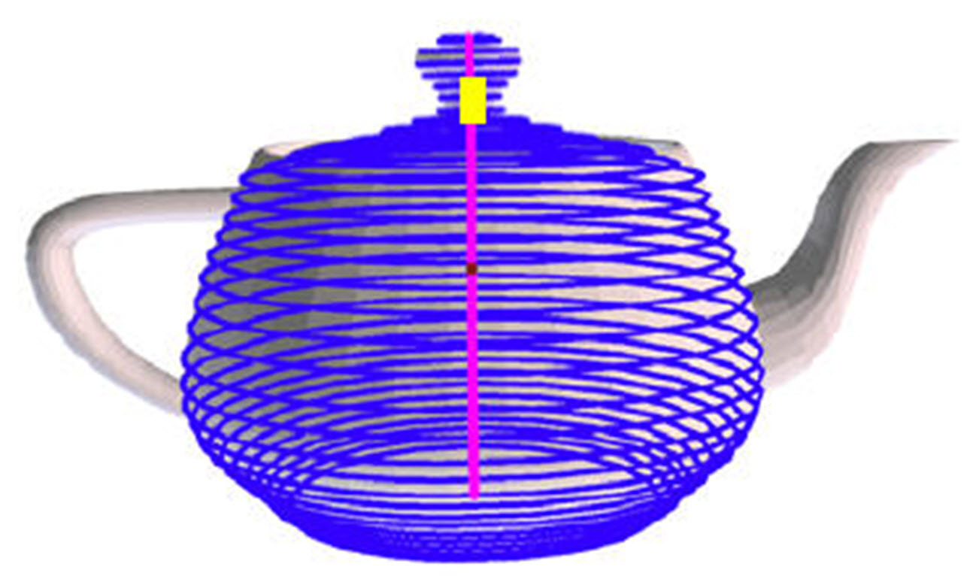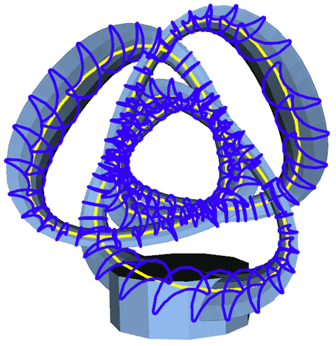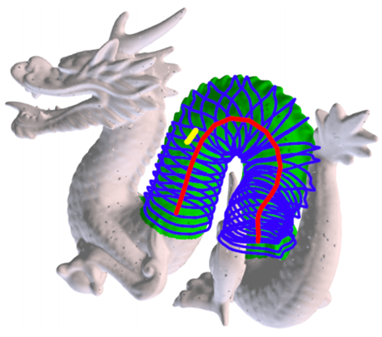
(a) (b) (c)
Figure 5: Sweep extraction: (a) rotational sweep, (b) progressive sweep on a geometric sculpture,
(c) progressive sweep on a “biological” shape.

- Optimization
Good design, as well as good lasting art work, often results from a carefully optimizing of an initial conceptual design. A first phase of optimization clearly takes place in the artists mind, and may depend on selecting a best possible combination of parameters for a particular design. But another round of optimization may take place within the CAD environment. This may be a purely mathematical or algorithmic optimization, and it may not require any detailed involvement by the artist. These optimization procedures can take many different forms [13]. As an example, I would like to discuss in some detail the optimization of smooth, free-form surfaces.
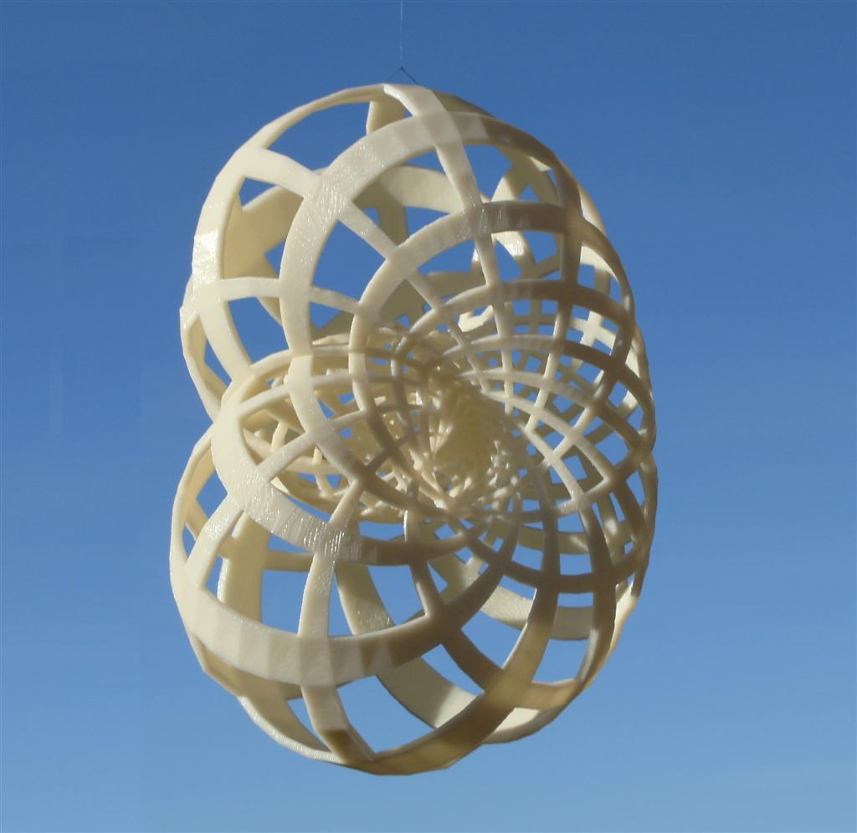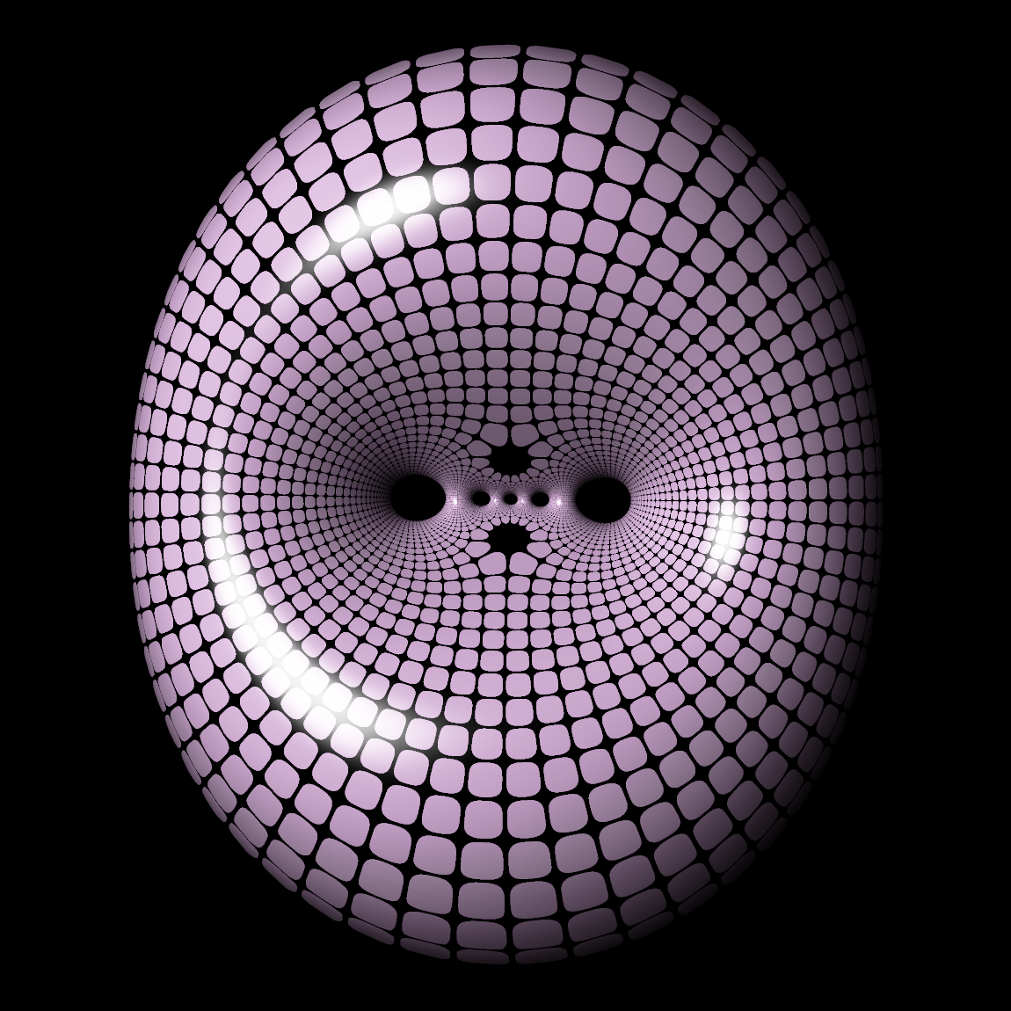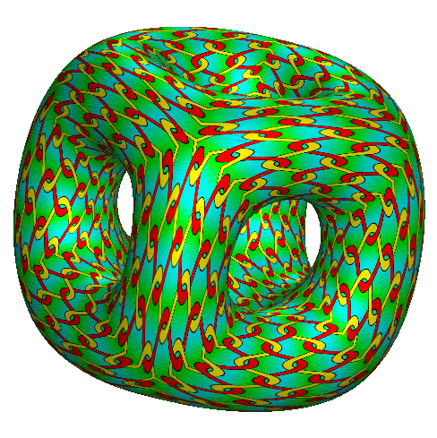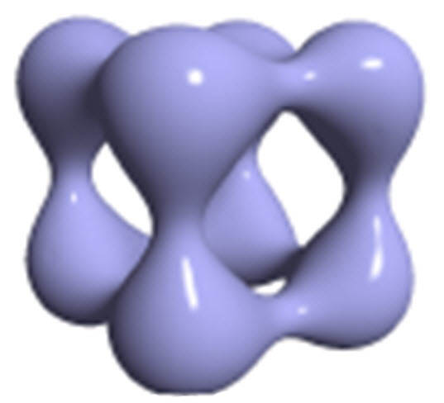
(a) (b) (c) (d)
Figure 6: Optimized surfaces: (a) MES_Klein bottle [15], (b) MES genus-5 button [31],
(c) MVS genus-5 cube frame [18], (d) a third-order functional [12] applied to (Figure 6c).

A classical way of optimizing the smoothness and aesthetic appeal of such a surface consists in letting it approximate a minimal surface (like a soap film suspended in a wire frame) or minimizing the bending energy in a thin-metal-sheet realization of such a surface [1]. Figure 6a shows the energy minimizing shape (MES) for a Klein bottle, and Figure 6b shows the result for minimizing the bending energy for a genus-5 surface; both geometries are due to Lawson [15]. But this particular functional, which corresponds to the integral of curvature squared over the whole surface, may not necessarily optimize the aesthetic appeal of the resulting shape; for higher-genus handle-bodies we obtain surfaces showing a “perforation ribbon” with small, tightly spaced pillars and tunnels (Figure 6b). Henry Moreton explored a more promising functional for aesthetic goals. His minimum-variation approach (MVS) [18] minimizes the integral over the square of the change of curvature. This assigns a zero penalty for a sphere, and it results in higher-genus handle-bodies that exhibit more substantial and more uniform toroidal arms (Figure 6c). Analyzing even higher-order derivatives of curvature, which is now practical with today’s powerful computers, give us additional freedom as to how we would like to optimize the shape of a free-form surface. Figure 6d resulted from an optimization process taking third order terms into account and trying to minimize the contributions of the first Fourier component (F1) of the second derivative of curvature [12].
- Mathematics as an Analysis Tool
Above I have described the role of math in the synthesis part of new art work. But math also comes in handy as an analysis tool. As mentioned at the beginning of this paper, scientists as well as artists often start with intense observation of some natural or human-made system. Understanding the inner workings of such systems may start by discovering repeated patterns and underlying symmetries in the presentation or behavior of such systems. Many papers at the annual Bridges conference [7] discuss the results of such structure-extraction, from ancient ornaments, musical scores, architecture, poetry, or dance patterns. Understanding these patterns may then serve as a stepping-stone for the generation of new, modified patterns, leading to new artistic output.

- Mathematical Visualizations
Mathematics not only serves as an analysis tool but also as an inspiration. It is used in the extraction of a generative paradigm, as illustrated with Figures 3 and 4, but it also can lead to sculptures that are mostly driven by a mathematical concept. For instance, the sculpture depicted in Figure 1d resulted from a design task assigned to a graduate class in geometrical modeling: “Create a Hilbert curve in 3D space.” This particular assignment is just one example of a larger class of 2D-to-3D analogy problems that I have explored with students [25]. They have resulted in spherical yin-yang shapes, “Borromean” tangles with more than three loops (Figure 8b), and surfaces that spiral in two orthogonal directions. Other fertile mathematical topics that can lead to attractive sculptural objects are the regular and semi-regular polytopes in three (Figure 7a) and higher dimensions (Figure 7b), Möbius bands (Figure 7c) and Klein bottles (Figure 7d), simple knots (Figure 8a) and links (Figure 8b), regular maps (Figure 8c), and 3-dimensional lattices and tilings (Figure 8d). As demonstrated in hundreds of Bridges papers [6], there is a nice symbiosis between art and mathematics.
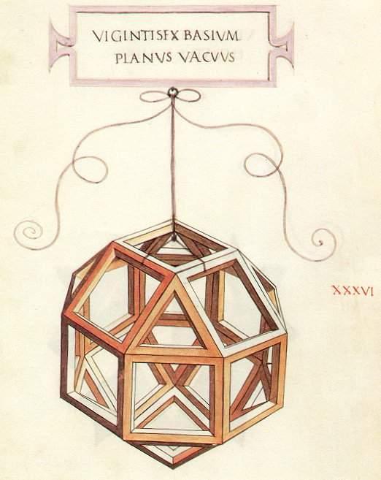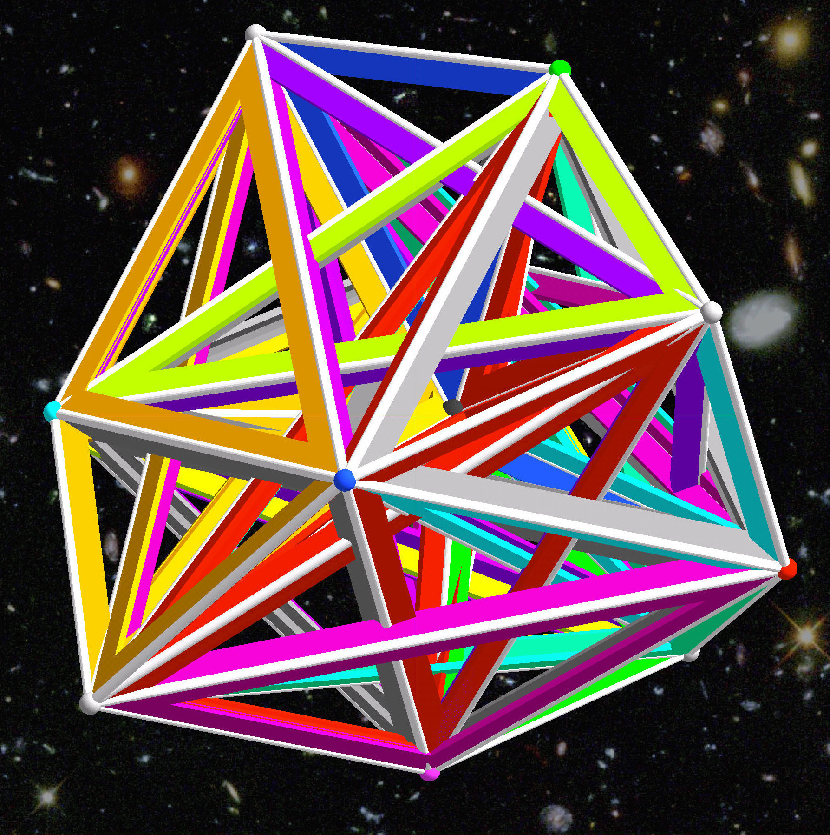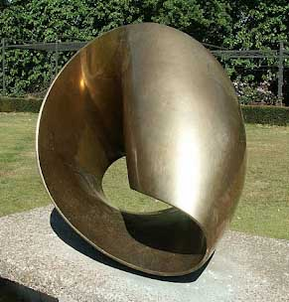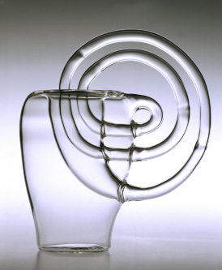
(a) (b) (c) (d)
Figure 7: Mathematical visualization models: (a) Rhombicuboctahedron (Leonardo [16]), (b) 10-dimensional 11-Cell (Séquin [27]), (c) Möbius band (Bill [5]), (d) Klein bottle (Bennett [4]).

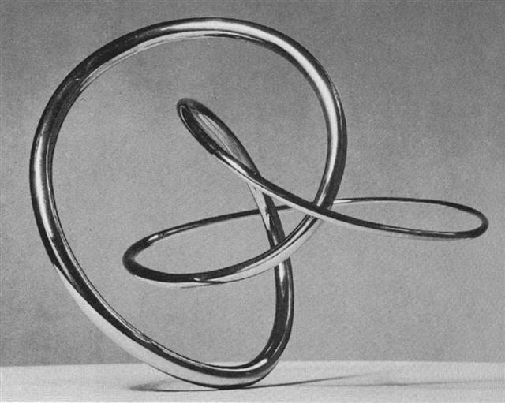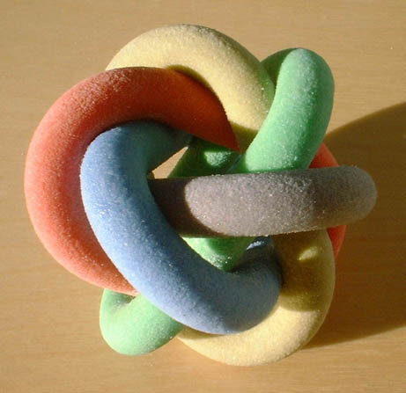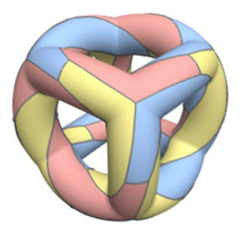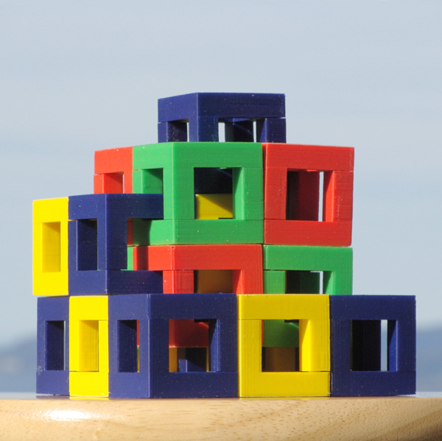
(a) (b) (c) (c)
Figure 8: More mathematical visualization models: (a) Knot-3₁ (de Rivera [20]), (b) “Borromean_5” link (Séquin [25]), (c) Genus-5 regular map (van Wijk [32]), (d) Isohedral 3D tiling (Séquin [26]).
- Conclusions and Future Trends
The realm of “art-math” has very fuzzy bounds, because the domains of “art” as well as “math” themselves have no clearly defined boundaries. Does the portrait of a mathematician or a poem bemoaning the non-convergence of an optimization algorithm belong into this domain? Does every trace of symmetry or every hint of a generative rule automatically assign an object into this domain? Clearly not every computer-designed 2D or 3D artifact belongs here either. But even with a rather conservative definition of these bounds, there is still a lot of interesting territory to explore.
The patterns and characteristics that assign an artifact to this “math-culture” domain are typically amenable to capture and reproduction by computing machines, even if the creator of such an object did not actually use a computer; this applies to most examples depicted in Figure 2. Thus we will probably see a continual increase in the use of computers in the papers submitted to the Bridges conference.
The design and optimization approaches discussed in this paper rely heavily on CAD programs. In the near future these programs will get even more powerful and more sophisticated. They are based on profound mathematical algorithms. But in a well-designed CAD environment this mathematical complexity is hidden from the user, who will interact with such programs at ever higher levels of abstraction. Thus, mathematics will become an effective but invisible amplifier supporting and magnifying the creative ideas of many artists – even if they have no formal training in mathematics.
For researchers who are inclined to use mathematical thinking, more powerful math-based methods and tools will allow them to probe more deeply, to find new connections, and to obtain a deeper understanding of complex physical, biological, or societal systems. This, in turn, may result in new insights and concepts that can be transformed into novel and advanced artistic designs.

Acknowledgments
I would like to thank my fellow Bridges board members, George Hart, Craig Kaplan, and Reza Sarhangi, for constructive comments on earlier drafts of this paper.

References
- F. J. Almgren and J. E. Taylor: The Geometry of Soap Films and Soap Bubbles. Scientific American, July 1976 pp 82–93.
- J. Andrews, H. Jin, and C. H. Séquin: Interactive Inverse 3D Modeling. Computer-Aided Design and Applications, Vol 9, (2012).
- Bab el Mansour Gate, Meknes, Morocco. – http://commons.wikimedia.org/wiki/File:Bab_Mansour_gate.jpg
- A. Bennett: Surface Model. – http://www.sciencemuseum.org.uk/objects/mathematics/1996-544.aspx
- M. Bill: Endless Ribbon (1953-56). Middelheim Open Air Museum for Sculpture, Antwerp.
- Bridges Archive: Online repository of conference papers. – http://archive.bridgesmathart.org/
- Bridges Organization: home page. – http://www.bridgesmathart.org/
- B. Collins: Evolving an Aesthetic of Surface Economy in Sculpture. Leonardo 30, 2, pp 85-88, (1997).
- M. Emmer: The Visual Mind II. MIT Press, Cambridge, MA, 2005
- G. K. Francis and B. Collins: On Knot-Spanning Surfaces: An lllustrated Essay on Topological Art. Leonardo 25, 3&4, pp 313-320, (1992).
- G. Gibbons: Rapid Prototyping. Interview concerning Additive Manufacturing (2011). – http://www2.warwick.ac.uk/knowledge/engineering/rapidprototyping/
- P. Joshi and C. H. Séquin: Energy Minimizers for Curvature-Based Surface Functionals. CAD Conf. Proc., Waikiki, Hawaii, pp 607-617, (June 2007).
- C.S. Kaplan and R. Bosch: Operations Research in the Visual Arts. Wiley Encyclopedia of Operations Research and Management Science, John Wiley & Sons, Inc. (2010).
- S. Kim: Ambigrams. – http://www.scottkim.com/inversions/
- H. B. Lawson: Complete minimal surfaces in S³. Ann. of Math., Vol. 92, pp. 335-374, (1970).
- Leonardo da Vinci: Open-face rhombicuboctahedron (1496). – http://www.georgehart.com/cccg/rpgm.html
- K. T. McDonnell, H. Qin, and R. A. Wlodarczyk: Virtual Clay: A Real-time Sculpting System with Haptic Toolkits. Proc. Symp. on Interactive 3D Graphics, pp 179-190, (2001).
- H. P. Moreton and C. H. Séquin: Functional Optimization for Fair Surface Design. Computer Graphics 26 (Proceedings SIGGRAPH'96), pp 167-176, (Aug. 1992).
- I. Peterson: Fragments of Infinity. John Wiley & Sons, Inc, New York, NY, 2001.
- J. de Rivera: Construction #35. (1956). – http://www.askart.com/askart/d/jose_de_rivera/jose_de_rivera.aspx
- B. Rollings: Swirled walnut turning, inset with bone. – http://www.wgo.ca/newsletters/2011_09.pdf
- H. F. Scherk: Bemerkungen über die kleinste Fläche innerhalb gegebener Grenzen. Jour. Reine Angewandte Mathematik, 13: pp 185-208, (1835).
- C. H. Séquin: Virtual Prototyping of Scherk-Collins Saddle Rings. Leonardo, Vol. 30, No. 2, pp 89-96 (1997).
- C. H. Séquin: Art, Math, and Computers: New Ways of Creating Pleasing Shapes. Bridges Conference Proc., pp 1-10, Winfield, KS, (July 1998).
- C. H. Séquin: Analogies from 2D to 3D – Exercises in Disciplined Creativity. Bridges Conference Proc., pp 161-172, Winfield, KS, (July 1999).
- C. H. Séquin: Intricate Isohedral Tilings of 3D Euclidean Space. Bridges Conference Proc., pp 139-148, Leeuwarden, The Netherlands, (July 2008).
- C. H. Séquin: A 10-Dimensional Jewel. Gathering for Gardner G4GX, Atlanta, GA, March 28-April 1, 2012.
- SLIDE design environment. – http://www.cs.berkeley.edu/~ug/slide/docs/slide/spec/
- K. Snelson: Needle Tower #2 (1969). Kröller Müller Museum, Otterlo, Holland. – http://kennethsnelson.net/category/sculptures/towers/
- J. Stark: Trinity. – http://jenstark.com/#13
- Uni Tuebingen: Surface Gallery. – http://www.math.uni-tuebingen.de/user/nick/lawson/
- J. J. van Wijk: Symmetric Tiling of Closed Surfaces: Visualization of Regular Maps. Proc. Siggraph 2009 Conf., New Orleans, pp 49:1-12.

