An Arch Rock Internal Draft Document

A Water Sensor for the Arch Rock Sensor Node
This application note illustrates how to use a conventional conductive water sensor with the Arch Rock Primer Pack Sensor Node to detect standing or flowing water and generate an alert. This low cost water sensor can prove very useful in a number of applications such as data centers where it can provide an early warning of flooding or condensation from the cooling system; homes for the elderly where even a film of water on the bathroom floor could pose a hazard; and industrial environments where conductive fluids are carried in pipes prone to corrosion or stress related failure. Figure 1 illustrates such a water sensor and an example application of it.

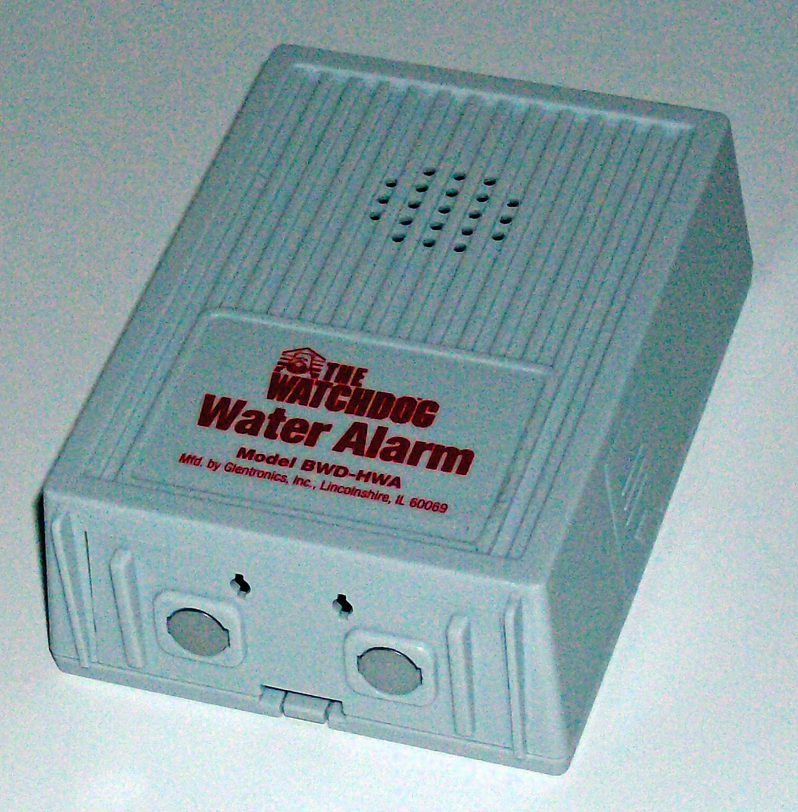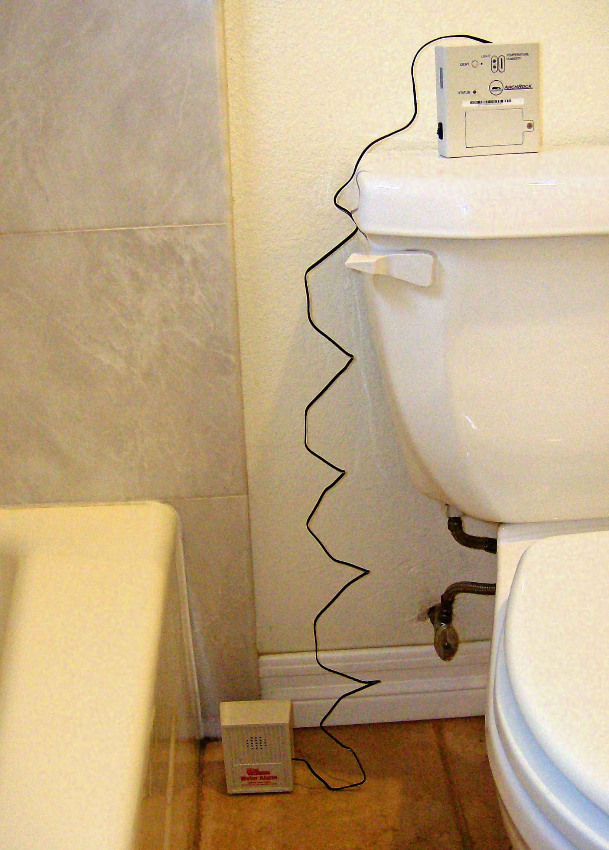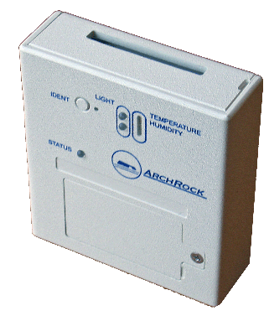

Figure 1 Water Sensor Application Example

Off-the-shelf water sensors operate by detecting conductivity across two electrodes at the base (see Figure 1 left). When dry, the circuit is “open”. When water is present between both electrodes, the circuit is closed and an internal battery and electronics serve to activate a loud alarm.

In the wireless application of this concept, we replace the audible alarm with an Arch Rock wireless Sensor Node. The two electrodes are simply connected to one of the digital inputs of the Sensor Node’s expansion interface, with a “pull-up” resistor applied to the input. When water is present and the circuit is closed, the state of the input changes from 1 to 0 and an event is generated by the Sensor Node. This event can then trigger an email or SMS alert. The state of the sensor may also be periodically polled using Arch Rock’s web services APIs or by direct TCP/UDP connection to the Sensor Node itself.

To outfit a Sensor Node with a water sensor, please follow these steps:
- Procure a conductive type (as opposed to a float type) water sensor. One source is the Basement Watchdog Water Alarm (model BWD-HWA), manufactured by Glentronics, Inc. of Lincolnshire, IL, USA, http://www.basementwatchdog.com/water_alarm.htm, and available at retail at Home Depot, ACE, and other home hardware stores in the USA.
- Open the water alarm by loosening four screws on the back. See Figure 2.
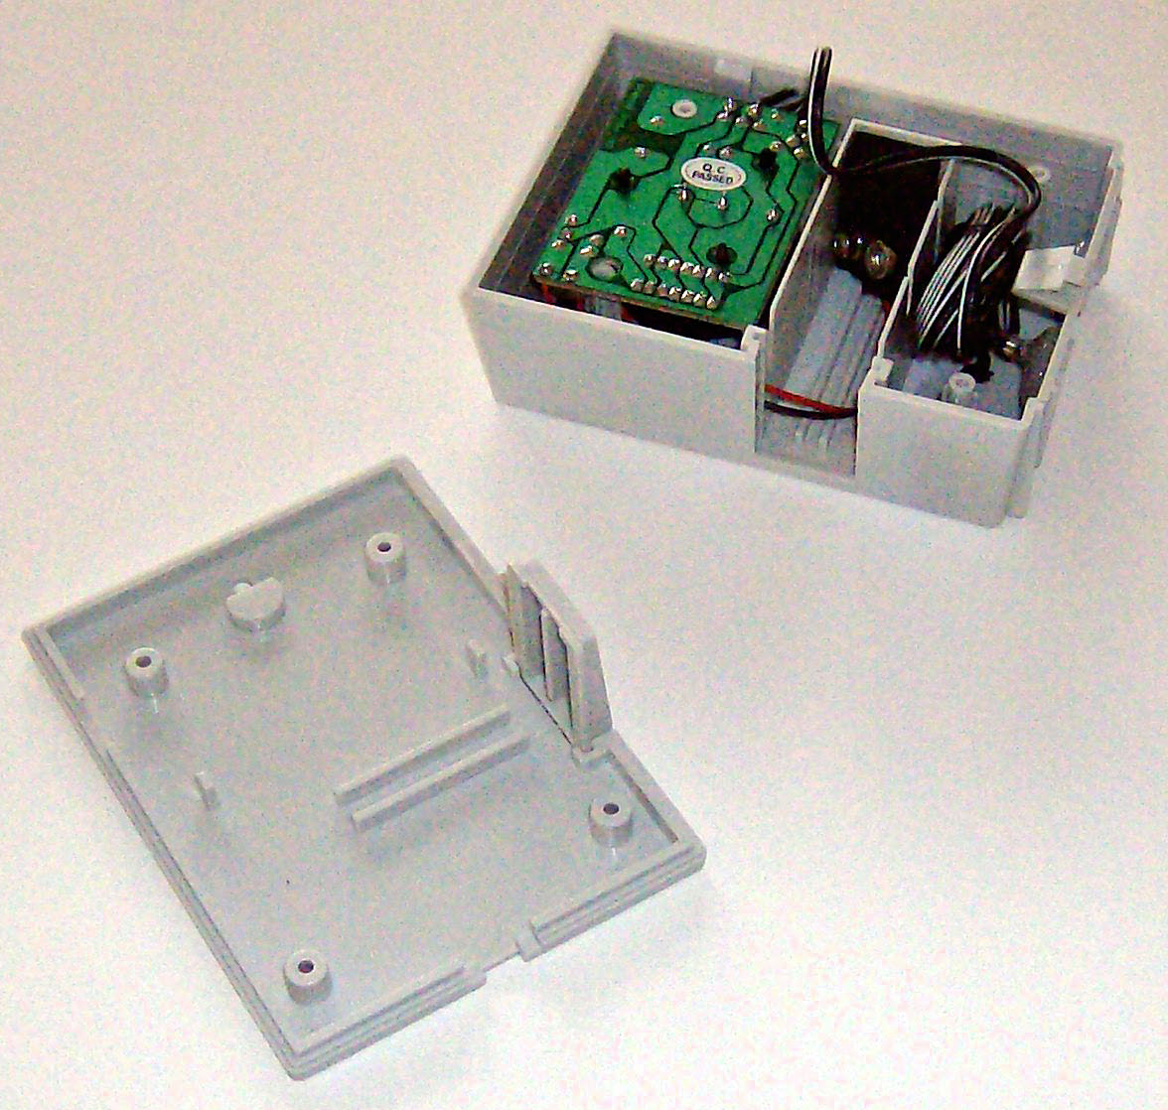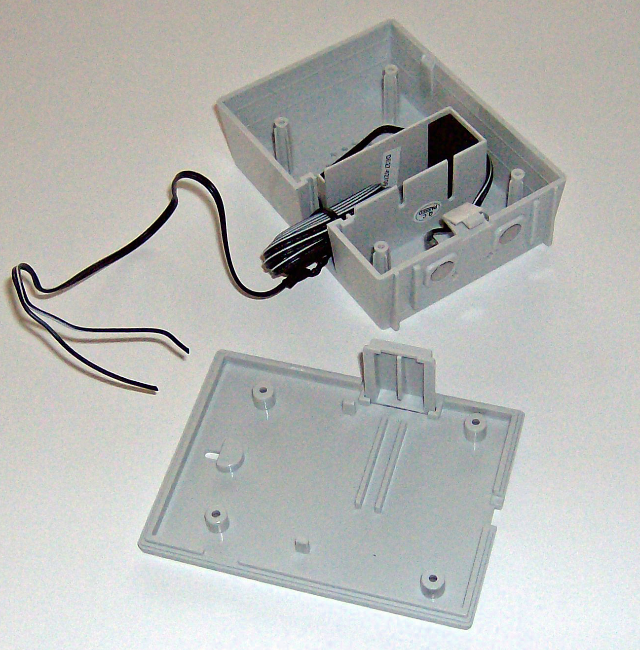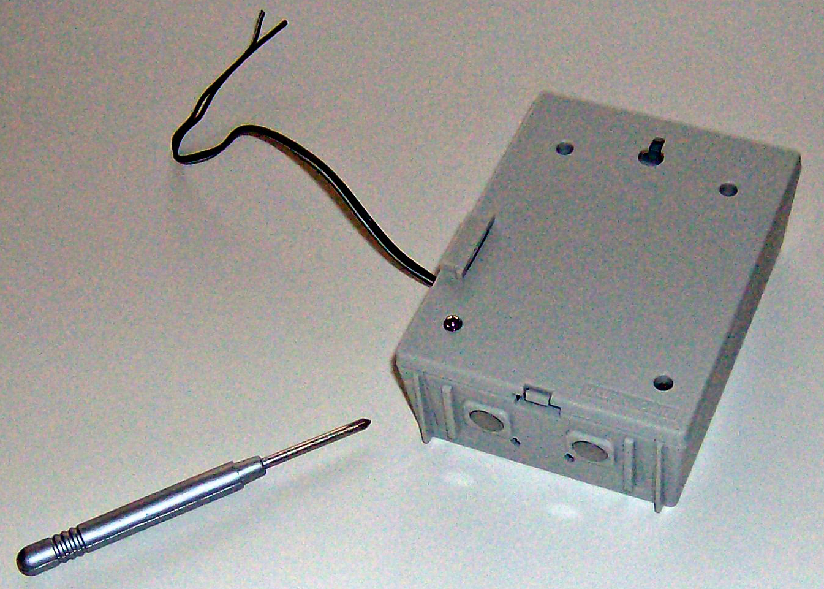
Figure 2 Water Alarm Modification
- Locate the wire connecting the base (with the two small steel tabs) with the electronics / speaker assembly. See Figure 2 left.
- Cut this wire as close to the electronics assembly as possible. Remove and discard electronics assembly along with the battery connector.
- Place the length of wire from the electrodes in the battery compartment. See Figure 2 center.
- Close the cover and reinstall screws. See Figure 2 right.
- To deploy the water sensor in an Arch Rock Wireless Sensor Network, connect it to the expansion interface of an Arch Rock Sensor Node.
- Open the sensor node. See Figure 3. Work the wires from the water sensor through the opening in the back cover of the enclosure.

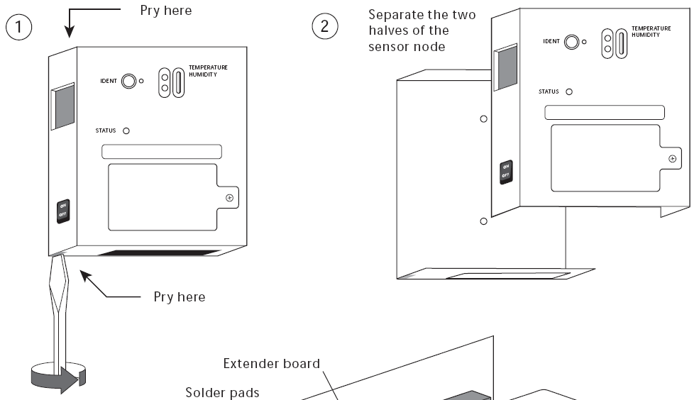
Figure 3 Opening the Sensor Node
- Connect one wire to the GND terminal of the expansion interface.
- Connect the second wire to the IO0 terminal.
- Connect a 1M Ohm “pull-up” resistor between the IO0 terminal and the Vcc terminal.
- Reattach the cover to the sensor node.

You are now ready to deploy the water sensor with the AR Sensor Node.

Arch Rock CONFIDENTIAL
HTN-0020 Draft 0.1 MT, 24 November 2026

