An Arch Rock Internal Draft Document

Wireless Networked Biometrics -- Heart Rate and Body Surface Temperature Monitor
This note illustrates how a wearable, wireless, personal heart rate monitor and body surface temperature sensor may be constructed for Arch Rock’s Primer Pack/IP. Personal biometric sensors may play a key role in increasing the safety of incidence response personnel in fire-fighting and rescue, monitoring the health of military personnel and combat troops in the field, monitoring the condition of recovering hospital patients, or remotely monitoring the elderly in home-care situations. Figure 1 shows an example of the application of the biometric monitor. This solution was recently demonstrated live at the IPv6 Summit 2007 in Herndon, VA, USA.

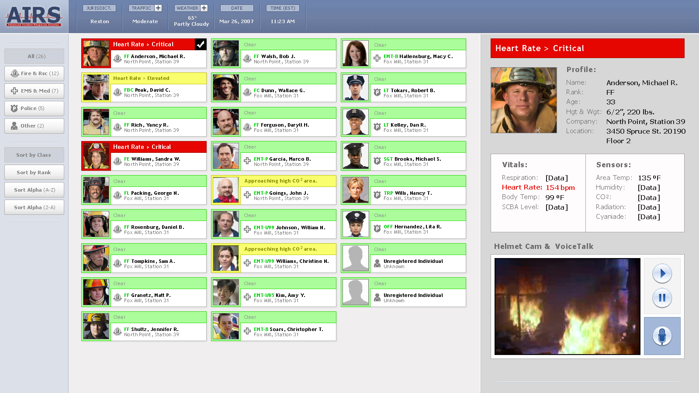
Figure 1 Biometric Sensor Application Example

This biometric sensor uses readily available, off-the-shelf sensor components with some modifications. These sensors are then connected to an Arch Rock Primer Pack Sensor Node via its external sensor interface. The final component of the solution is a custom Arch Rock software image available from Arch Rock upon request, to count and display the heart rate in Beats per Minute. The following figure shows the final product.

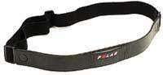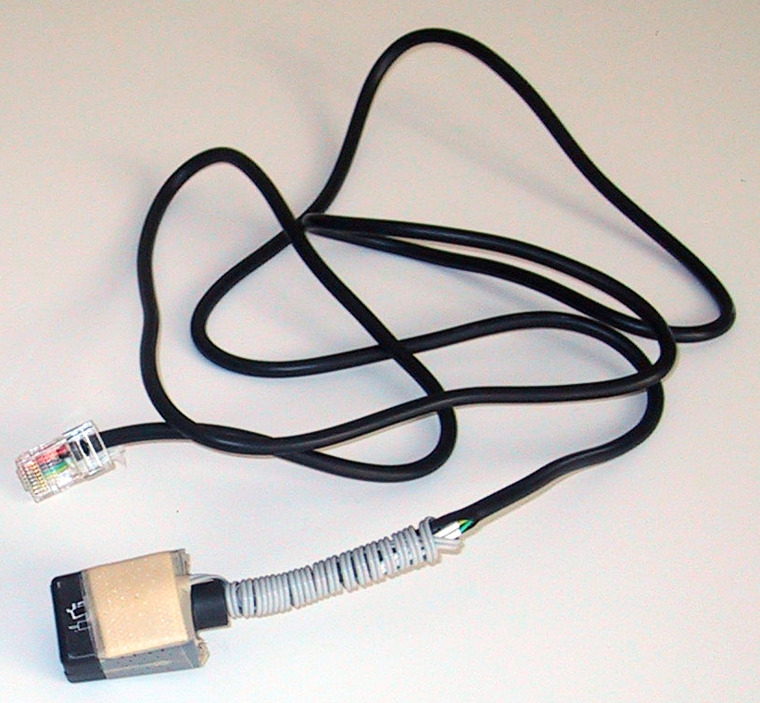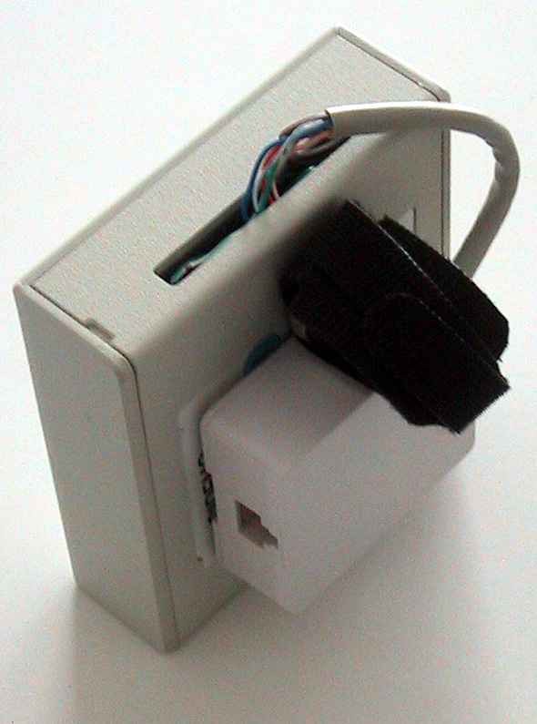
Figure 2 Wireless Biometric Sensor components

The biometric sensor consists of a chest strap (at left), a heart rate “receiver” plus temperature sensor (center), and the Arch Rock Wireless Sensor Node (at right). The chest strap detects the human heart beat and emits a low frequency radio signal with each beat. The receiver detects the radio pulse emitted by the chest strap and transmits a low voltage signal with each pulse, to the AR Sensor Node. The Sensor Node counts voltage pulses and converts them to a Beats per Minute (BPM) value. This value is available directly from the Sensor Node via TCP/UDP services, or else from the AR Gateway Server via the Arch Rock web services API, as well as in the AR web GUI.

Here is how to build this sensor. You will need to have some basic level experience with soldering and building networking cable assemblies (RJ11, RJ45). You will need some basic electronics tools such as a soldering iron, wire stripping and cable construction crimping tool, etc. These are readily available at local electronics stores such as Radio Shack and Fry’s.
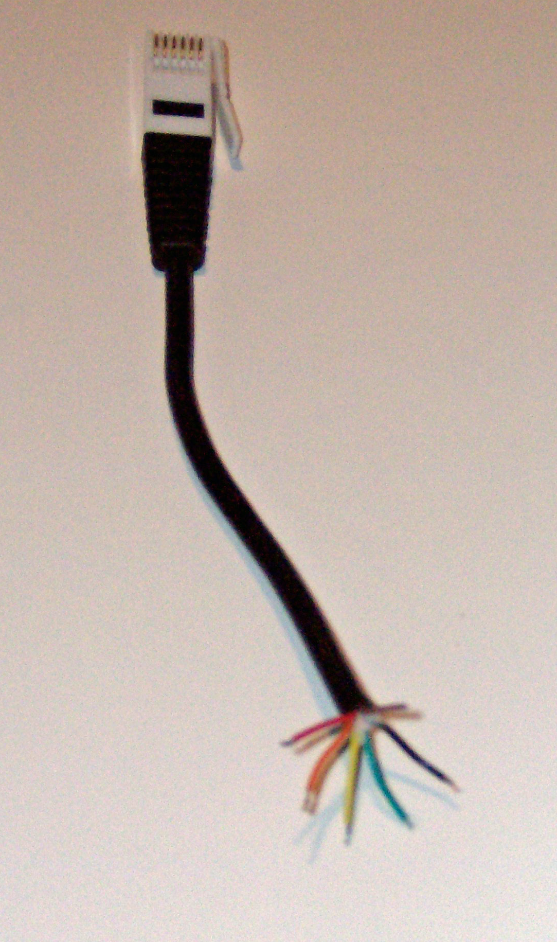
- Procure a commercial heart rate monitor with an external “receiver” (not integrated into a wrist watch unit) from Vernier Software and Technology, of Beaverton, Oregon, USA. http://www.vernier.com. The components required are: Chest Belt Transmitter (CBT) and Heart Rate Receiver (HR-REC). Note: An optional component is the Go-Link (GO-LINK) USB Sensor Interface for a personal computer. This product and included software will allow you to view your heart rate on a PC using USB, prior to permanently modifying the Heart Rate Receiver (HR-REC) for the Arch Rock Sensor Node. Please note that after applying the modification outlined in this application note, the HR-REC will no longer work with Go-Link. However the Go-Link unit will still be useable for other sensors available from Vernier.
- Procure a thin-film RTD type thermal sensor for measuring body external temperature. One source is U.S. Sensors: http://www.ussensor.com/prod_rtds_thin_film.htm. The part number is PPG102A1.
- Modify the Vernier part HR-REC to be an integrated heart rate receiver and body external temperature probe. Cut the cable near the connector end, leaving as much length of cable on the receiver side as possible. The cut end will look like the figure at left. Discard this stub and work with the receiver cable.
- Strip the sheath at the cut end and expose a 1 inch (2 cm) length of all six wires. Align and cut the wires flush, and using a suitable crimping tool, consolidate them into a RJ45 cable connector. See Figure 2 center. Please be sure to make the following pin assignments of the six color coded wires:

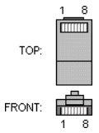 | Pin | Wire Color | Usage
 | 1 | Black | heart rate receiver -- Ground
 | 2 | Red | heart rate receiver -- Voltage pulse output
 | 3 | Orange | heart rate receiver -- Vcc
 | 4 | Green | RTD sensor -- Ground
 | 5 | Yellow | RTD sensor -- Resistance output
 | 6 | Brown | Not used
 | 7 |  | Not used
 | 8 |  | Not used
Table 1. RJ-45 pin assignments
- Prepare the RTD thermal sensor for integration with the HR-REC unit. Solder a short (1 ft, 25 cm) two-conductor wire to the RTD sensor. Prior to soldering, slip on short lengths (0.5 inch or 1 cm) of heat shrink tubing on the two ends of the cable to insulate the RTD leads after soldering. Solder the two wires of the cable to the RTD. Slide the heat shrink tubing as close as possible to the RTD and secure in place using a heat gun.
- Prepare the HR-REC cable for integration with the RTD cable. Using a craft knife (e.g. “X-acto”), very carefully make a 1 inch (2cm) slit in the sheathing of the six wire cable, approximately 2 inches (4 cm) from the HR-REC unit (see Figure 2 center) Separate out the Green and Yellow wires only, and carefully cut them. Strip the sheathing from the RJ45 connector end of each wire by about 1/8 inch (2mm). Using heat shrink tubing for insulation, solder the 2 wires of the RTD sub-assembly created in the previous step to the stripped green and yellow wires of the HR-REC cable.
- Combine the RTD thermal sensor with the HR-REC to create the HR-RTD assembly. Wrap the RTD cable around the end of the HR-REC cable, and tape the RTD to the HR-REC pick-up unit, making sure to expose the RTD sensor only. The final assembly is shown in Figure 2 center.
- Prepare the Sensor Node to connect the HR-RTD assembly. Create a RJ45 female connector assembly (see Figure 2 right), using the EIA/TIA 568B wiring standard and a 4 inch (10cm) length of CAT-5 cable (see Table 2). The RJ45 connector assembly may be procured from Radio Shack.

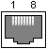 | Pin | Wire Color | Usage
 | 1 | White w/Orange Stripe | heart rate receiver -- Ground
 | 2 | Orange | heart rate receiver -- Voltage pulse output
 | 3 | White w/Green Stripe | heart rate receiver -- Vcc
 | 4 | Blue | RTD sensor -- Ground
 | 5 | White w/Blue Stripe | RTD sensor -- Resistance output
 | 6 | Green | Not used
 | 7 | White w/Brown Stripe | Not used
 | 8 | Brown | Not used
Table 2 RJ45 Female connector pin assignments

- Attach the socket assembly to back of the Arch Rock WSN node using double-sided foam adhesive tape or velcro. See Figure 2 right.
- Connect the wires to the AR Sensor Node Expansion Interface. Open the sensor node. See Figure 3.
- Strip the sheathing from the last 2 inches (5cm) of the free end of the CAT-5 cable (opposite end from the RJ45 female connector) and separate the 8 color coded wires. Work the wires thru the slot in the back cover of the sensor node enclosure.
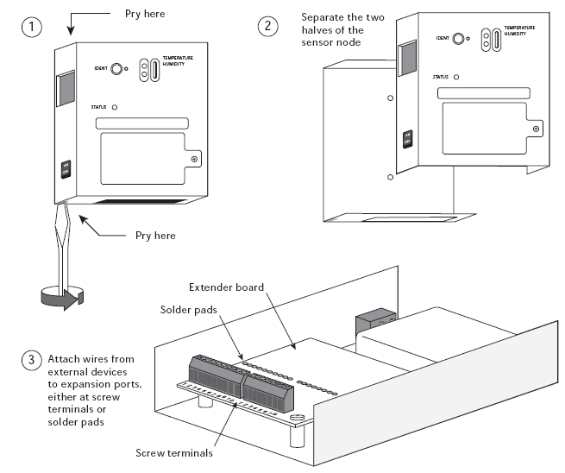
Figure 3 Opening the Sensor Node

- Connect the wires to the Sensor Node Expansion Interface as shown in Table 3.
- Connect a short “jumper” wire between the ADC0 and VPU0.

 | Pin | Wire Color | 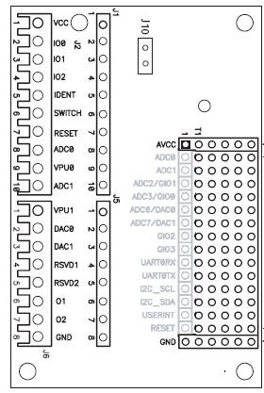 | Terminal | Usage
 | 1 | White/Orange Stripe |  | GND | HR -- Ground
 | 2 | Orange |  | IO0 | HR -- Voltage pulse output
 | 3 | White/Green Stripe |  | VCC | HR -- Vcc
 | 4 | Blue |  | GND | RTD -- Ground
 | 5 | White/Blue Stripe |  | ADC0 | RTD -- Resistance
Table 3 RJ45 Female connector pin assignments

- Attach a belt strap for the sensor node using the two holes in the back half of the enclosure and nuts and bolts as needed.
- Carefully close the sensor node enclosure.
- The final product should look like Figure 2 right.
- Next, obtain the appropriate Arch Rock software for the Gateway Server, Bridge and Sensor Node, that supports the HR-RTD.
- Reprogram the gateway server and sensor node with this software image, and restart the Gateway Server and Bridge.
- Enable the IO0 and ADC0 external sensor for the Sensor Node you just modified.

In the Arch Rock Gateway Server GUI, you are now ready to monitor biometrics using the Arch Rock Sensor Node you just created. Put on your chest strap, place the HR-RTD receiver next to your skin at convenient location (under-arm, waist, neck, etc.), and turn on the sensor node. It should blink RED whenever it detects a heart beat. If it does not, or blinks erratically, take off the chest strap, moisten it with salty water and put it on again. The node should now blink steadily with each heart beat.

The RTD temperature will be reported in units of “cts”. This is a raw count that will need to be converted to temperature in ˚C or ˚F in software. The procedure for conversion is described below.
<TBD>

Arch Rock CONFIDENTIAL
HTN-0010 Draft 0.1 MT, 23 November 2026

